ARC Film Quiz

For your chance to win a pair of cinema tickets (redeemable in 2021, in line with COVID guidance), plus two free drinks, popcorn, and a giant film poster… Answer as many of our film questions as you can, and return your entries to box.office@arconline.co.uk
Name …………………………………………………………………………………………………..
Address …………………………………………………………………………………………………..
Phone …………………………………………………………………………………………………..

Popular past ARC cinema screenings…
- Which film, starring Himesh Patel, is set in a world where the Beatles never existed?
- Which 2020 film gained 10 Oscar nominations, and was partially shot on location at the Tees Barrage?
- Who played the title role in the 2006 film, The Queen?
- Which film won four awards at the Academy Awards in 2020, including Best Picture and Best Director?
- How many years was there between the release of Bill & Ted's Bogus Journey and Bill & Ted Face the Music?
- Which 1990’s computer game character appeared on ARC’s cinema screen in 2020?
- In Tenet, John David Washington's character had a name that he only referred to himself as. What was it?
- Which actor portrays John Wick in the film series of the same name?
- John Adedayo Bamidele Adegboyega starred in which blockbuster film, shown at ARC in early 2020?
- Which film tells the story of a group of women who form a choir, whilst their partners are in Afganistan?
Classic films…
- Which classic British film ends with the line: ‘Hang on a minute lads, I’ve got a great idea’.
- Which classic star is known for films including The Gold Rush and City Lights?
- Who played the lead role of Rick in Casablanca?
- In 1940, Hattie McDaniel became the first African American actress to win an Oscar, for her role in which epic film?
- What is the name of the second James Bond film?

Modern classics…
- Which film features the line: “I’m also just a girl, standing in front of a boy, asking him to love her”?
- What is the second rule of Fight Club?
- What is the name of the popular clique in Mean Girls?
- Judi Dench won an Oscar for her supporting role in Shakespeare in Love. How many minutes did she appear on screen for?
- Begbie, Renton, Sick Boy and Spud are characters from which film?

Family favourites…
- Who voiced the character of Nala in the live action version of The Lion King?
- What is the name of the spell used by Ron and Hermoine in Harry Potter and the Philosopher’s Stone to make their feathers fly?
- What is the name of the little girl in Monsters Inc.?
- What is the name of Anna and Elsa's kingdom in Frozen?
- How many different musical troll tribes do Poppy and Branch discover in Trolls World Tour?

Picture round… What is the title of the film?

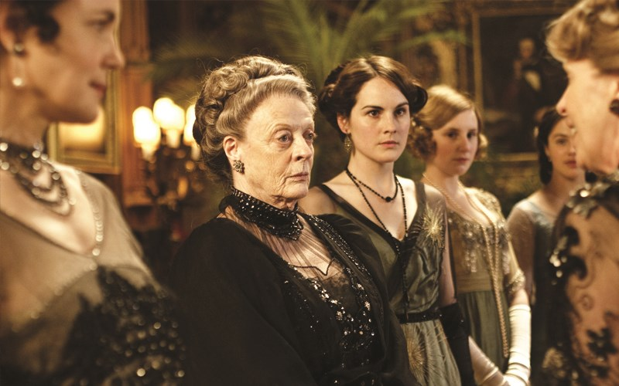 | 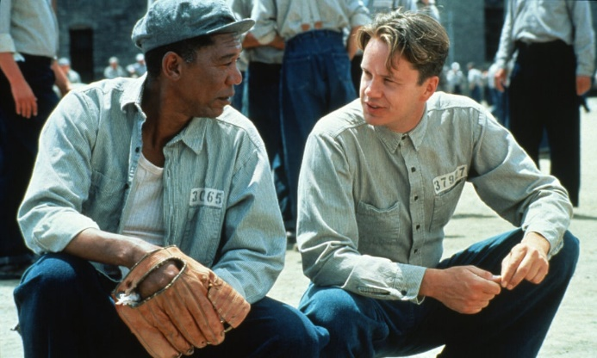
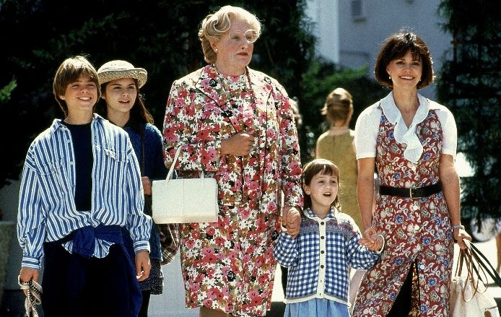 | 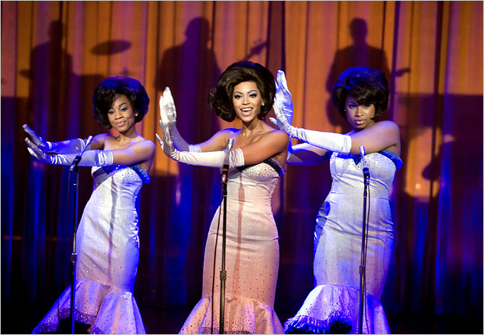
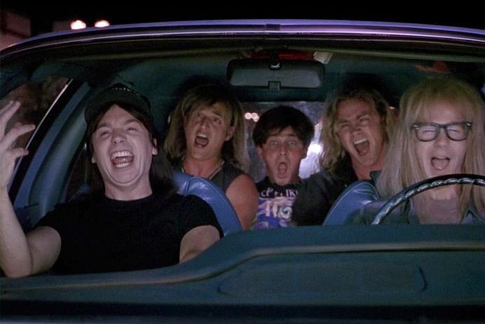 | Thanks for taking part!

