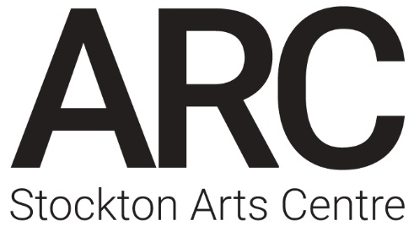
ARC Getaways

Name of artist/company:
Contact name:
Preferred pronoun:
Postal address:
Postcode:
Telephone number:
Email address:
Website:
Main artform:

Artist/company biography (approx 250 words)

What do you want to use your ARC Getaway for? (approx 250 words)

Why do you want to do this work at ARC, and how does it contribute to our artistic policy? (approx. 500 words)

Please tell us the names of the people who will be at ARC, and their roles:

Please tell us about any access requirements:

Please indicate your first choice of dates/rooms, with other options if they are possible for you:
 | w/c | Workspace | No of bedrooms required
1st Choice
2nd Choice
3rd Choice

Please return by email to artist.development@arconline.co.uk

