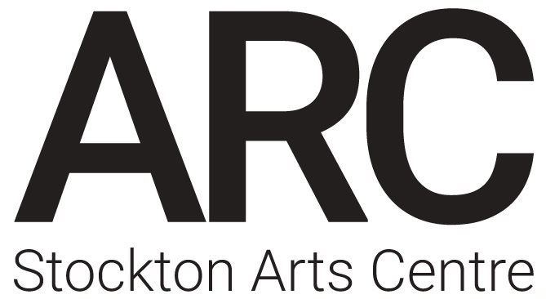
ARC Stockton Work Experience (4 - 8 July 2022) Application
Name:
Age:
Gender:
Pronouns:
School/College/University:
What are you currently studying?
What is your favourite lesson/module and why?

Tell us a little bit about yourself (hobbies, interests etc)
What are your current career aspirations?

Why would you like to do work experience at ARC?
What do you want to get out of the week?

