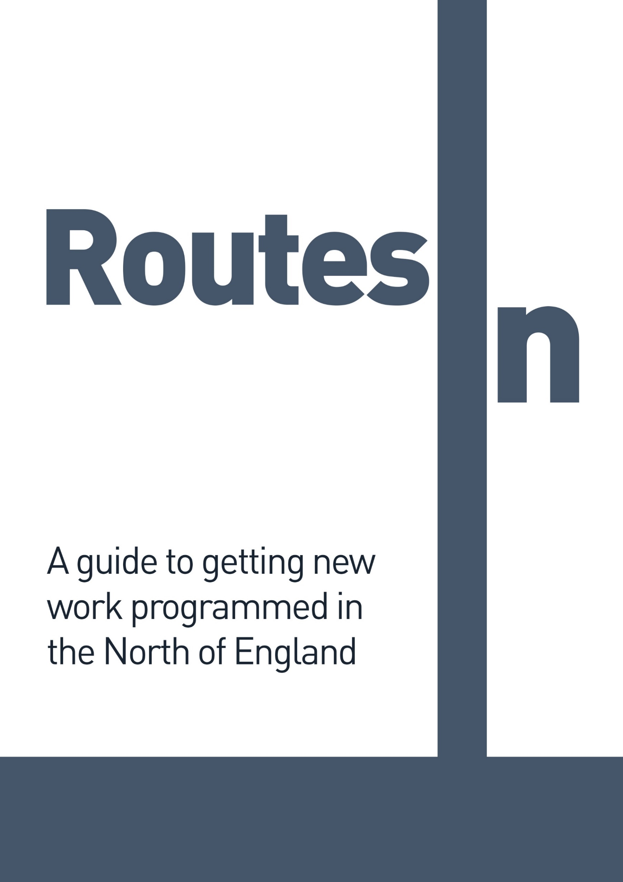

Published by Venues North
2022
Table of Contents
Introduction 4
General Information 5
What is Venues North? 5
What do we mean by ‘new work’? 6
How do Venues North members support artists? 6
Which programmers should you talk to? 6
How do you get to know programmers? 6
What should you ask programmers for? 7
Inviting programmers to see your work 8
When do programmers programme? 8
What do programmers want to know? 9
How are programming decisions made? 10
How does the money work? 10
Identifying audiences 12
Reaching audiences 13
The impact of COVID-19 14
Venue Information 15
Alphabetti Theatre…………………………………………………………………………...…………….. 16
ARC, Stockton Arts Centre 21
Arts Centre Washington 27
The Civic, Barnsley 29
Cast, Doncaster 31
Contact, Manchester 34
The Edge Theatre & Arts Centre 37
Enable Us – University of Sheffield 39
Harrogate Theatre 42
HOME, Manchester 45
Hull Truck Theatre 49
Lawrence Batley Theatre, Huddersfield 52
The Liverpool Everyman and Playhouse 54
Liverpool’s Royal Court 57
Octagon Theatre Bolton 60
Oldham Coliseum Theatre 62
Live@theLibrary at Oldham Libraries 64
Royal Exchange Theatre 66
Sheffield Theatres 69
Slung Low – The Holbeck 71
Stephen Joseph Theatre 74
The Dukes, Lancaster 76
The Lowry 79
Theatre by the Lake 83
Theatre in the Mill 85
Theatre Royal Wakefield 88
The Old Courts Wigan / Square Chapel Halifax 90
Unity Theatre, Liverpool 92
The Viaduct Theatre 94
York Theatre Royal 96
Z-arts 98
Genre Matrix ………………………………………………………………………….................100

Introduction

Getting work programmed is hard; getting new work programmed is even harder. Without a known title, famous actors or national reputation, persuading programmers to take a risk on your new show can be challenging. There is a sense of the touring landscape shifting, as we seek to find ways of offering audiences a deeper, more meaningful engagement with touring work, resulting in new and different relationships between artists and venues.
This guide has been put together to help artists and companies making new work overcome some of the barriers to getting their work programmed.
We can’t promise it will help you book a 20 date national tour, but we hope it provides a useful insight into programmers and programming and helps you in your approach to venues.
There is one key piece of advice:
Be targeted in your approach
A blanket approach to venues is unlikely to net results. Being more targeted in approaching venues that have appropriate programmes, policies, spaces and audiences for your work will save you lots of time and energy in the long term. We hope that some of the information included in this guide will help you do that.
You are far more likely to be successful in getting venues interested in your work if you set out to develop relationships rather than just sell them a show. Think about your core purpose, and that of the venue, and if there is a match, then think about how you can benefit each other.
Once you have identified a target list of venues, start to develop a relationship with them. Be clear about what your rationale is for approaching those venues and be prepared to have honest conversations.
Being successful doesn’t have to mean touring to 20 different venues; it might be having really good, strong, meaningful relationships with six. Every programmer who does support your work has the potential to be a champion for it, so invest in these relationships.
We look forward to getting to know you and your work.
Annabel Turpin
Chair
Venues North

General Information

What is Venues North?
Venues North is a network of venues from across the North of England who are committed to supporting artists to create new work. Our aim is to work together as venues to support new and emerging artists from the North to get their work more widely seen regionally, nationally and internationally.
Venues North is not a closed network or an exclusive group of venues, but open to any venue in the North that shares this commitment to artist development and new work.
Current members include:
- Alphabetti Theatre | - Slung Low’s Hub, Leeds
- ARC, Stockton Arts Centre | - Square Chapel Arts Centre, Halifax
- Arts Centre Washington | - Stephen Joseph Theatre, Scarborough
- Bolton Octagon | - Sunderland Culture Company
- Brewery Arts Centre, Kendal | - The Civic, Barnsley
- Cast, Doncaster | - The Dukes, Lancaster
- Centre for Live Art Yorkshire | - The Edge Theatre & Arts Centre, Chorlton
- Contact, Manchester | - The Lowry, Salford
- Gala Theatre, Durham | - The Octagon Centre, University of Sheffield
- Gosforth Civic Theatre | - Theatre by the Lake, Keswick
- Harrogate Theatre | - Theatre Delicatessen, Sheffield
- HOME, Manchester | - Theatre in the Mill, Bradford
- Hull Truck Theatre | - Theatre Royal, Wakefield
- Interplay, Leeds | - Unity Theatre, Liverpool
- Lawrence Batley Theatre, Huddersfield | - University of Salford
- Leeds Playhouse | - Viaduct Theatre, Dean Clough, Halifax
- Live Theatre, Newcastle | - Waterside Arts Centre, Sale
- Liverpool Everyman & Playhouse | - York Theatre Royal
- Liverpool's Royal Court | - Z-Arts, Manchester
- Northern Stage, Newcastle
- Oldham Coliseum
- Oldham Library Studio
- Royal Exchange, Manchester
- Sheffield Theatres

Venues North members meet three times a year to share our learning around supporting artists, and to champion the artists we support. In addition to publishing this guide, the group has also supported new work made in the North being presented at the Edinburgh Fringe Festival, through publishing annual guides highlighting work supported by member venues and running an inaugural Venues North award in 2019. We are currently planning future activity, taking into account the post-pandemic landscape.

What do we mean by ‘new work’?
By new work, we mean new theatre and performance, usually devised work or new writing, or work that explores the boundaries of theatrical form.
We recognise that whilst dance can sit within this definition, and many of our members programme dance, there are specialist development agencies supporting dance in the North. We have included their details below.

How do Venues North members support artists?
The individual venue information below lists many ways that Venues North members support artists. The overarching ethos of Venues North, which all members have signed up to, is that we will, whenever and wherever possible, do the following:
- talk to artists, and respond when they contact us
- be honest, even if that means saying no or that we don’t like someone’s work, or we don’t think it is good enough
- be clear and transparent in what we offer in terms of support for artists
- signpost artists to other people if we can’t help them

Which programmers should you talk to?
Every venue is different, and the more targeted you can be in selecting which venues to approach, the more likely you are to get a response. The information about each venue included below should help with this but do have a good browse around each venue’s current programme and see whether you think your work is really likely to fit.
Also, look at the tour schedules for other another artist or companies who you think make work that might appeal to similar audiences as your own, and consider approaching these venues.
Know your geography – and if you don’t, buy a map! Many venues have exclusion clauses, either because they share audiences or want their programme to complement rather than replicate that of nearby venues, so do take this into account before approaching venues or ask about catchment areas and exclusion clauses early in your conversation.

How do you get to know programmers?
Performance is based on a relationship between artists and audiences, and programmers are, momentarily at least, at the centre of that relationship. Therefore, if your work is designed to be presented in a programmed venue, building a relationship with programmers is the first stage in building a relationship with potential audiences.
Approaching programmers can be hard, but Venues North members are committed to ensuring they are accessible to artists. Aside from direct contact via phone or email (see venue information below for individual preferences on contact methods) here are some other ways of getting to know programmers:
- At gatherings of programmers and artists (eg festivals and showcases)
- At shows – programmers often see work in their own venue, so attending a show at their venue and asking for a meeting beforehand is a good tactic
- At scratch nights – programmers interested in new work often attend scratch nights, which are run regularly in the North by The Civic in Barnsley, The Edge, Hull Truck, Liverpool Everyman and Theatre by the Lake in Kendall.
- Via social media – follow programmers on Twitter or Facebook and join or initiate conversations
- At special events for artists, such as The North East Exchange, Push Festival, and Pitch Parties at The Lowry.
- At the bar – where programmers can often be found pre and post show, both for informal and curated discussions

What should you ask programmers for?
Programmers aren’t necessarily going to offer you a two week run in their venue the first time they meet you. In fact, they probably aren’t even going to offer you one night. Offering programmers a range of opportunities to get to know and support your work can help you develop a longer term relationship. Ask them to:
- Come and see your work – and feedback
- Watch an extract online – and feedback
- Come and see you perform at a scratch night
- Come and see a work in progress sharing
- Talk to another programmer who has seen your work
- Introduce you to other artists/creatives
- Have a coffee and a ‘no obligation to book your work’ chat
- Show you round their venue
If your budget permits, hiring space within a venue for R&D/rehearsals can also be a good way of getting to know an organisation, providing a risk-free opportunity for programmers to get to know you and your work.
As the relationship develops, ask if they can:
- Offer you a slot at their scratch night
- Offer you any R&D or rehearsal space
- Read through your promoters pack before you send it out
- Talk through your creative process/plans with you
- Help you identify your audiences and how to reach them
- Help you with your budget
- Read over a funding application for you
- Give advice on fees and financial deals
- Offer support with documenting the development of your work
- Act as an outside eye during rehearsals
- Help you develop and/or test associated outreach/wraparound activity
- Act as an advocate or champion for your work and talk to other programmers on your behalf
Like any relationship, it is really important not to force the pace, and to accept a ‘no’ if ultimately that’s the outcome. Be prepared to respond quickly and appropriately, but if you are asking for help or feedback on your work, set realistic timescales – especially if you are asking someone to read over a funding application for you.

Inviting programmers to see your work
It is always good to invite programmers to see your work but be realistic on your expectations of how many will be able to respond – there are only seven nights in any one week, and programmers have commitments to seeing work they have already programmed in their own venue as well as work elsewhere. Resources in terms of time and money are limited, so don’t be disappointed if programmers don’t come – but do invite them, and if they aren’t able to attend, do send them links to clips of the work online afterwards. Full length recordings are great but not every programmer can commit to watching hours of footage.
If programmers do come, don’t expect instant feedback – giving honest feedback is hard, especially if you are expected to give it straight after a show. Suggest in advance a follow up call or email within the next few days, to give them a chance to think about the show and structure their feedback.

When do programmers programme?
One of the most difficult questions programmers get asked is ‘when will you be programming the [insert season]?’
Here are some possible answers:
- When I know whether I have got funding next year or not
- When I know whether this enormous potential project is going to happen or not
- When I have finished writing this funding application
- When I get back to my desk with an hour to spare to look at some potential shows
- When I get time to watch all the DVDs I’ve been sent
- When I have finished my financial/HR/operational tasks
- When someone tells me about a show I am really excited about
- When I see a show I really want to book
- When I know what’s out there
- When I have enough potential shows on the table to make a decision about the balance of the programme
- When the companies I have provisionally booked know about their funding
Programming rarely happens at a set time, especially as many programmers aren’t just programmers, but also act as chief executives, directors, finance and HR managers, building managers and so on. Marketing deadlines sometimes force a flurry of activity, but this doesn’t necessarily relate to when programmers make decisions.
The short answer is: there is no specific time, other than ‘when I have time, and before the marketing deadline’.
The best answer we’ve been able to come up with is a jigsaw analogy ‘when I have enough of the pieces available to know what the picture might look like’.
Neither of these answers are particularly helpful if you are trying to book a tour. However, in the venue information below, each programmer has indicated how far in advance they would prefer to be contacted, when their seasons run and what kind of response you should expect if you do approach them. We hope that helps a little.

What do programmers want to know?
Generally, when artists and companies approach programmers, they send information about themselves and their show – what is it about, what does it look like, when is it available. This is essential information but there are some other things that programmers often want to know, such as:
- Why are you making this show?
- Why are you touring now?
- Who is the show for?
- How will you be selling it to them? (copy/image)
- How can you support the venue to reach those potential audiences?
- Why do you want to visit this venue?
- What kind of financial deal are you looking for?
- A sense of the scale of the show
- What your expectations are in terms of audience numbers
- How is it staged and what kind of technical resource do you need?
- Is the show/tour dependent on funding, and if so, when will funding be confirmed?
- Which other venues are you talking to/where else are you going?
- Who has seen already seen your work? Do you have any endorsements from other programmers and artists?
If you can answer some or all of these questions as part of your initial approach, it is likely to help programmers decide whether the show is right for their venue or not.
Remember that ‘copy’ is for selling the show to audiences, and will be used as text in brochures, on leaflets and websites but at the initial booking stage, programmers require a different perspective on your work. A brief description of the work, synopsis of the story and your thinking behind the show, how you want audiences to experience or feel about your work is far more useful.
Don’t feel that you have to use ‘funding application’ language. Many programmers are interested in process as well as the production itself, so answering the ‘why’ and the ‘how’ are-you-making-it questions are as important as the ‘what’ are you making.

How are programming decisions made?
Whilst fees and availability are key factors in decision-making for programmers, there are many other factors that play a part, such as:

- Commitment to other shows
- Balance of programme
- Audience potential
- Mismatch of need/perception
- Staffing restrictions
- Staging and technical requirements
- Sales pitch
- Quality
- Personal taste
- Geographical factors
- Status of show in terms of funding

Even the font you use in your promotional pack can be a real turn-off!

How does the money work?
Most people – artists and programmers - feel a little awkward when it comes to discussing money, which often leads to an unnecessary level of confusion. Don’t be afraid to own up if you don’t know, it is always better to clarify things early in the negotiation process rather than further down the line when it is too late.
Financial deals
Generally, venues will offer one of the following deals:
- A guaranteed fee - an agreed amount that they will pay you regardless of how much box office income there is
- A guaranteed fee plus travel and accommodation
- A box office split – a percentage of the box office income, often after deductions
- A guarantee against a split – this means they will pay you either an agreed amount or a percentage of the box office, whichever is greater
- A guarantee plus a split – an agreed amount they will pay you regardless, plus a percentage of the box office
- A hire – you pay them an agreed amount, and you retain all the box office income
- A first call against a split – you (or sometimes the venue) have a ‘first call’ on the box office income up to a certain level, and once that is reached, the rest is split between you on an agreed percentage. There can sometimes be a ‘second call’ in the other person’s favour before the split.
When agreeing deals, it is always good to ensure that as much detail as possible is agreed. For example, when agreeing travel and accommodation costs, it is worth spelling out how many people this is for, travelling to/from where and how many rooms are required.
e.g., A guaranteed fee of £500 plus travel (standard class rail travel or equivalent, return to Manchester x 2 people) and accommodation (two singles x one night)
Always clarify if the fee is + VAT or not; if you aren’t VAT registered, you won’t be charging VAT but if you are VAT registered and the venue isn’t, it does make a material difference to the venue.
If splits are expressed as 70:30 or 60:40 always check in whose favour they are, ie do you get the 70% or the 30%.
If shorthand is being used for deals (e.g. £500 vs 70%), make sure you are clear what it means, and whether VAT is being deducted or not.
Examples
Scenario:
150 tickets have been sold @ £10 each, providing a total box office income of £1,500.
VAT @ 20% (£300) is deducted, leaving £1,200 of box office income, net of VAT
On a 70:30 split, you would receive 70% of £1,200 = £840
On a £500 guarantee vs a 70:30 split, whichever is greater, you would also receive £840, as that is greater than the guaranteed fee of £500
On a £1,000 guarantee vs a 70:30 split, you would receive £1,000 as that is greater than 70% of the box office income
On a £500 guarantee plus a 70:30 split, you would receive £1,340 (£500 guarantee plus £840, which is 70% of the box office income)
On a first call to you of £500 then a 70:30 split, you would take the first £500 of the box office income, leaving £700 to be split, of which 70% is £490 so you would receive a total of £990
On a first call to the venue of £500 then a 70:30 split in your favour, the venue would take the first £500 of box office income leaving £700 to be split, so you would receive £490 (70% of the remaining £700)
On a deal where there was a first call to you of £500, then a second call to the venue of £250, then a 70:30 split in your favour, you would take the first £500 of box office income, leaving £700; the venue would take the next £250, leaving £450, which would then be split 70:30, so you would get a total of £815 made up of £500 + £315 (70% of £450)
Risk
The difference between these deals is essentially about where the risk sits: a guaranteed fee means the risk sits with the venue, as if they don’t achieve enough box office income to cover the fee, they have lost money. A hire means all the risk sits with you – if you don’t receive enough box office money to cover the hire fee, you have lost out.
Box office splits, guarantees against a split and first calls against a split are all ways of sharing the risk, which means both parties have a vested financial interest in selling tickets.
Deductions
Box office income is usually subject to some deductions, such as:
- VAT – currently 20%, which means 20% of the box office income is deducted (and paid over by the venue to HMRC) before the percentage split is calculated
- Credit card commission – usually a percentage or flat rate, to cover the card processing costs incurred by the venue
- PRS - a deduction to cover the venue’s contribution Performing Rights Society for the rights to play music during the show
Contras
Contras or ‘recharges’ are costs incurred by the venue which are charged back to the visiting artist or company. These are usually more applicable to mid-large scale productions, for example, expenditure on marketing, technical support or get out costs specific to your show. Always ask during the negotiations whether there will be any contra charges.

Identifying audiences
Who is the show for, and how can you help venues reach those audiences are the most difficult questions to answer, but also the critical ones. No venue has a ready-made audience for new work that will just pay their money and turn up. Developing audiences for new work is a long-term project for venues, and artists and companies are critical to this process.
The more specific you can be about who you think the audience for your work is, the better able programmers are to decide whether they might be able to get an audience for your work. It also means that if your show is booked, venues are able to work with you to deliver targeted marketing and audience development campaigns.
It can feel uncomfortable to be specific about who you think the audience are, as if in some way you are indicating you don’t want other people to come. We all want ‘everyone’ to feel that they can come to your show, but the reality is that not everyone will and the more specific you can be, the more successful marketing and promotional activity will be.
Sometimes it is useful to describe your audiences to programmers by likening your work to that of other artists and companies, i.e. my work is likely to be enjoyed or appeal to audiences of work by XX, XX and XX.
You can also use your development process to help identify audiences, through scratch nights, sharings, work in progress performances and other connected engagement activity. It is important to identify in advance what the aims of these activities are, who you are looking to engage with and why, and then to capture and be able to articulate what you have found out.
Venues can help you define your audiences, so if you have venue partners on board during the development of your work do ask for support with this. Looking at their audiences for similar work and asking them to share appropriate data with you will strengthen your audience development plans, both for funding applications as well as approaches to other venues.

Reaching audiences
Once you have identified your potential audience, then you need to work out how to reach them. What will your own activity look like, and how can that complement activity undertaken by the venue? What will the communication between you and the venue’s marketing staff look like? Invest in this relationship, it is a key one to achieving success.
Do set expectations of what success will look like at the outset – how many people are you realistically expecting to attract, and does that match the venue’s own target?
Think about the language you use in your description of the show – is it familiar to the audiences you are trying to reach?
Where else might these audiences be, if they aren’t at the theatre? How else might they spend their leisure time? What do they watch on TV or at the cinema? What else might they be interested in?
Increasingly ‘depth of engagement’ is becoming a key consideration, so programmers aren’t just interested in the number of people who might come and see your show, but also what the opportunities are for them to engage with it.
This doesn’t just mean offering a traditional devising workshop for local schools/colleges but being open to a much wider range of engagement with the venue’s audience and local community. Are you willing to talk to local artists, to open up your rehearsal room or share your practice with them? Are there opportunities for local students and artists to respond to your work by creating their own? Can audiences engage with the show and its themes online, either before or after the show? Will this involve passive activity – watching an online trailer, reading your rehearsal room blog – or active engagement – contributing their own thoughts, material, responses?
Developing audiences is a partnership between artists and venues. Do be realistic about the capacity of the venue to support you with this, as sometimes additional outreach activity can feel like it is adding to everyone’s workload rather than supporting it. Offering a free workshop at the last minute because tickets aren’t selling is not helpful!
Do your research – find out about existing education, outreach and creative learning programmes, ask what the venue’s priorities are and what has worked in the past and then plan your activity – in advance - accordingly.

The impact of COVID-19
We are all coping with the impact of COVID-19 and are likely to be living with the consequences for some time to come.
For many venues, the pandemic has made it more difficult to make commitments or provide certainty around their future artistic direction as they try and navigate a very different landscape, not least financially. It has also highlighted many of the inequalities and issues in our sector. Consequently, we are not necessarily trying to get back to where we were before but forge a different and better pathway forwards. Many are in the process of working out what this looks like.
We know this is the same for artists, companies and other creative freelancers too. We hope Venues North can play its part in developing a mutually supportive sector rooted in a spirit of honesty and openness.

Venue Information
The information below is subject to change but will be updated annually.

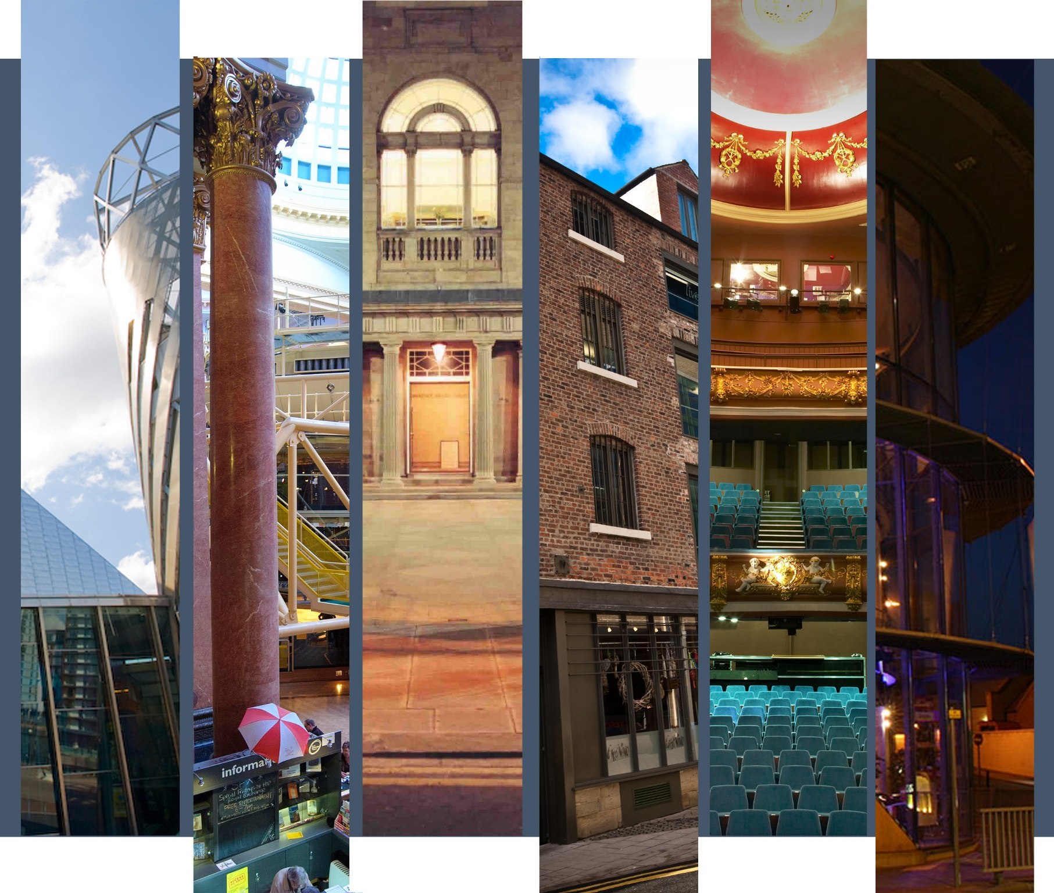

Programmer’s Contact Details |  | 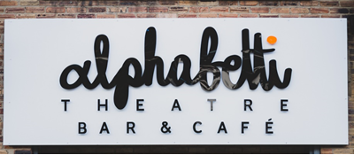
Name: | Ali Pritchard
Position: | Artistic / Executive Director
Tel: | 0191 261 9125
Email: | programming@alphabettitheatre.co.uk  ali@alphabettitheatre.co.uk  admin@alphabettitheatre.co.uk
Alphabetti Theatre

Artistic Policy
Alphabetti Theatre is an award-winning artist led multipurpose performance space in Newcastle upon Tyne. Our building is repurposed, previously a rubber stamp factory, we were built by our local community and local artists, on a shoestring budget. This created our much-loved DIY aesthetic in our building and both DIY, and is a space for great art, which we believe should be for everyone not just those who can afford it – so all our performances are charged at pay what you feel. Our year-long programme of work consists of 230 theatre, 100 artist development, 44 music, 24 Comedy, 24 Cabaret performances. We have minimal financial resources but what we do have, we will pass onto to our artists. We co-produce 90% of the work that is on our stages and very rarely have theatre productions that are touring, if we do program touring work it will only be via a larger partner festival.

Evening Theatre program: This is work predominately aimed at adult audiences. We tend to program 12 productions per year with each production running for 3 weeks (18 performances). Each of these productions will be co-productions with Alphabetti and will rehearse and premier at Alphabetti. We aim to programme 12-18 months in advance and want to be a creative co-producer / partner, so we are working with the artist at the start of an idea and conception of a creative process. This way we can support and guide them through funding, marketing, community engagement, producing, developing, creating and finally performing the show. This means we very rarely will program a finished piece of work. Each of these productions are used as inspiration around the remaining work in the building from one night music, cabaret and comedy performances to artist development opportunities and community engagement work. All these productions will have as a minimum 1 audio described, 1 captioned and 3 relaxed performances.

Family Theatre program: This work is predominately aimed at family audiences with children 12 years and under. We tend to program 3-5 productions per year to co-inside with school holidays, with each production running for roughly 3 weeks (18 performances). Each of these productions will be co-productions with Alphabetti and will rehearse and premier at Alphabetti. We aim to programme 12-18 months in advance and want to be a creative co-producer / partner, so we are working with the artist at the start of an idea and conception of a creative process. This way we can support and guide them through funding, marketing, community engagement, producing, developing, creating and finally performing the show. This means we very rarely will program a finished piece of work. Family programming is relatively new to Alphabetti but since our first family show in 2017 we have built a steady and regular audience and reputation for high-quality work that is affordable to all, this has led to 2021 every family production selling out. When we program family theatre, we will also have an evening show running at the same time, so the theatre and the backstage facilities will be shared by both creative teams.

We select artists and companies to work with based on the content, style of their work, if it is a good fit for our company and space. We often identify artists through one of our artist development streams. Additionally, we try to see as many performances as we can, so invite us to your work. We won’t program that show but we may be interested in being part of your next project.

Music, Cabaret & Comedy programming: We do not program mixed bill events, we’re looking for artists in these genres that have 45 – 90mins of material that make up a full show. We program music, cabaret and comedy on 9.30pm slots on Friday & Saturday nights predominantly on our stage in the bar the D’Addario Stage. We want to encourage audience crossover and development for the artists, it also provides vital income from the bar as it keeps audiences in the building for longer. This programming is inspired by the “core” theatre show that is on so we look at artists covering similar themes or crossover in creative teams. We program these events 4-6months in advance. We have a house cabaret troupe Bonnie & The Bonnettes / The House of Love.
How we support artists
Our aim is to support artists from starting on one of our artist development streams to evolving and over time being programmed as part of our “core” theatre program. We currently have three streams but we often have new opportunities so it is good to follow us on social media and subscribe to our mailing list.

Professional Premiers:
To be launched in January 2022, this event happens quarterly on the first Thursday of a run on The D'Addario Stage from 21:15 - 23:00. This is a place for emerging theatre makers to have a platform to build their professional credits and start a relationship with Alphabetti. It is short and simple application process either via a 3 minute video or max 2 sided document. From this we select 3 emerging theatre makers/ companies to showcase themselves, they each get a slot up to 20 mins long. We are looking for DIY work, this stage has its limitation for theatre so we want work that showcases the artist rather than worrying about big tech. We are launching this in January 2022, from there we will look to program this 4-6months in advance. Each slot receives:
- 33% of box office taken for the event
- A professional video recording of their performance.
- Professional photos
- Alphabetti provides a technician to support them in the day and operate each show.

Reaction Artist
This is funding dependent, we are trialled it in late 2021 to officially launch it in January 2022, from there we will look to program this 4-6months in advance. We have secured funding for the first 6 months and will continue to seek more funding to extend the program. This stream is there to develop under-represented artists in the performing arts ecology by this we mean (but exclusive or exhaustive):
- Identify as a woman
- Identify as LGBTQIA+
- Identify as a person who has experienced racism and are part of an ethic diverse background.
- Identify as living with a physical or cognitive disability.

Alphabetti commission an emerging theatre maker or company to create a short piece of theatre in reaction to the long running “core” theatre show that month. Alphabetti partner them with a mentor, they both come and watch the dress rehearsal, then they create a short complete piece of theatre (10-20 minutes) over the course of a week (tues - sat). They then tech and dress the piece on the Monday and then perform it 3 times after the “core” theatre show (Tues - Thurs) at 21:15.
What we offer the reaction artist & mentor:
- A run of 3 performances
- A £500 fee for the artist and £450 for mentor
- Free rehearsal space
- Artistic Support
- Technical Support, we provide a technician for the get in and to operate the performances.

Response Writing Competition:
This stream is funding dependent, it is produced in partnership with Just Write, they have received an Arts Council England project grant that has provided funds to run 5 competitions. This project grant currently ends in March 2022 although at time of writing we are already seeking additional funds to extend the program.
This is a writing competition, open to anyone over the age of 16, they could be emerging or established. All plays will be read blind and judged by the merit of the play. It's free to enter and the winning script receives a cash prize

How does it work?
- Writers come and watch one of the selected “core” theatre shows during the first week of performance (Tuesday - Thursday). When they arrive at the box office, ask for a Writer's Pack. This will contain information about who they're writing for, cast, director, any other conditions of entry and information about how to submit their script.
- They will then have until midnight that Friday to write a complete 10- 20 minute play responding to any aspect of the production they've seen – what they write is up to them, but they’ll have to follow the instructions in the pack carefully to be considered.
- Our Just Write creative team (Ben Dickenson, Mark Calvert, Paula Penman) will read the submissions and select a winning script. Unfortunately, due to the amount of entries we are anticipating, we are unable to offer notes.
- All applicants are notified by the Sunday of that week.
- The winning script goes into rehearsal for 1 week.
- It will then be professionally performed after the “core” theatre program during the third and final week of the run (Tuesday - Thursday).​

This is a stream for emerging directors and actors, the Just Write creative team hold quarterly workshops for directors and actors and from here they select the creative teams for each competition. For more information about our opportunities visit: https://www.alphabettitheatre.co.uk/opportunities

Spaces & Capacities
Venue | Capacity
Theatre | 80. Fixed seating in thrust (playing space 5mx5m)
D’Addario Stage | 80 Standing & Cabaret seating
Seasons
September - March
March - August
How far in advance to contact us
It is never too early.
We aren’t interested in booking…
Amateur Dramatics, touring work, finished complete productions.
The kind of financial deals we can offer
Each offer varies but on average we offer the following.
For Evening and Family Theatre:
- 18 performances (all charged at pay what you feel)
- A guarantee of £2,700 plus a second call box office split of 70/30 once net box office exceeds £3,860.
- £2,250 theatre tax relief advance plus any additional monies if the production’s rebate exceeds £2,500 after the claim has gone in.
- Free rehearsal space
- Input and Funding Application Support
- Artistic Support
- Community Engagement Support
- Technical Support
- Audience Development and Marketing support
- Support in making the production accessible.

For Music, Comedy & Cabaret:
- 1 – 3 performances (usually 1)
- A guarantee of £100 plus a second call box office split of 70/30 once net box office exceeds £200.
- Alphabetti provide technician
- Free rehearsal space (cabaret only)
- Theatre Tax Relief Rebate (cabaret only), this is not the advance like theatre but Alphabetti will process their claim.
- Artistic Support
- Technical Support
- Audience Development and Marketing support

We like to artists to make initial contact by…
It’s never too early to talk to us. We want to work with artists from the inception of an idea.
We prefer artists to contact us
By email | x | By phone | x | By post
Send weblink | x | Send DVD
If you approach us, you can expect…
A reply either suggesting a meeting or pointing you in the direction of other opportunities. We are a very small team so if you don’t get a response within a fortnight please follow it up with a phone call or another email we won’t mind.

Programmer’s Contact Details |  | 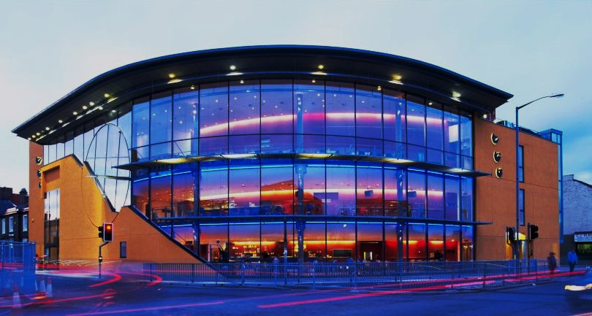
Name: | Annabel Turpin
Position: | Chief Executive & Artistic Director
Tel: | 01642 525181
Email: | Annabel.Turpin@arconline.co.uk

ARC, Stockton Arts Centre

Artistic Policy
ARC’s artistic policy is to present work that is contemporary and relevant. By that, we mean we want to show work that helps us understand and enjoy the world as it is today. We want to look forward, to excite audiences about the future. ARC’s programme currently encompasses the following:

Core programme
Our priority is to develop work at ARC for our audiences, to make sure it has a strong relationship with our local communities. Our core programme involves activity that we influence, that directly delivers our artistic policy.

This includes:
• projects and events developed with partner organisations
• community-led activity
• our programme of support for performance-based artists
• work created by our Associate Artists, including shows we tour to other venues
• other performance work developed in association with us

We present some of the newest and most exciting performance work being made in the UK today. Our programme features local, regional and nationally renowned artists and companies, who are making work that is relevant to our communities. Often, we bring work to ARC that challenges perceptions of what performance might usually look like, that offers audiences a different kind of experience to more traditional forms of theatre.

We don’t generally book work based around classic texts or adaptations, or that has historical themes. The majority of our programme is set in the modern day. We prefer to work with artists and companies during the development of work. This enables us to find ways of engaging audiences alongside the creative process, before presenting the final show. This means we are unlikely to be interested in booking a finished piece of work. Ultimately, we present work we are passionate about, so there are exceptions to everything.

We select artists and companies to work with based on the content and style of their work, if it is a good fit for our programme. We identify people to work with by attending festivals and showcases, meeting artists, listening to recommendations and seeing as many performances as we can.

Our core programme is usually booked around 12-24 months ahead. If you are interested in being part of our programme, please contact us at the earliest stage of developing your work.

Disabled-led work
ARC has a particular interest in disabled-led work. From 2015 – 2018, in partnership with Little Cog, we delivered Cultural Shift, a strategic programme of activity delivering new and increased opportunities for disabled people in the arts. Part of the legacy of the project is an ongoing commitment to ensure our cultural landscape is vibrant and representative of the people living and working in our communities. Within ARC's artistic policy, we have worked with Little Cog to develop a specific policy around disability work.

Our aims are:
• to challenge negative commonly held perceptions about disability and disabled people
• to involve disabled people in the arts at every level
If you are a disabled artist or are approaching us about work that considers disability, illness or mental health, please read our policy and watch our short film first, which you can find on our website under About Us/Artistic Policy. The work of disabled artists and participants in the programme may or may not have a disability focus, although we are ensuring that the work is disabled-led.

Family
ARC’s family programme is mainly focussed on work for under 7s. We present theatre, dance and puppetry performances on Saturdays approximately once a month. We co-commission a Christmas show for under 7s with the Albany in Deptford, and a February half term show with The Civic in Barnsley. Details of these opportunities will appear here on our website under Artists/Opportunities. Our family shows are usually booked at least 6 - 12 months ahead.

Music
ARC’s programme encompasses a wide range of music including rock, pop, soul, jazz, folk and indie. The Point is an ideal space for music, with a seated capacity of up to 400 and a standing capacity of 550. ARC also presents a monthly series of daytime classical concerts in association with Master Musicians, featuring young musicians from across the world. Concerts are usually booked at least six months in advance.

Comedy and light entertainment
ARC has a fabulous reputation for comedy amongst audiences and comedians alike. Some of the best comedians around knock on our door wanting to perform here.

You can see everything comedic at ARC:
• aspiring newcomers at our seasonal Beat the Gong events, where the audience gets to judge whether new acts get ‘gonged off
• circuit regulars at our monthly Catch 22 Comedy Club nights
• stand up favourites such as Chris Ramsey, Marcus Brigstocke and Jenny Éclair
• comedy legends like Lee Evans and Jack Dee, who have chosen ARC as a great venue to try out new material

Film
ARC’s film programme features a range of mainstream, arthouse and family films, independent and world cinema. We regularly host post-show discussions and Q&A sessions with guests. We also screen live broadcasts such as NT Live and other productions. Regular film screenings run Wednesday – Saturday, with matinee and evening screenings. One-off screenings take place on Monday and Tuesday nights, either as private hires or collaborations.

Exhibitions
ARC’s exhibition programme, which shown in the second floor Gallery, allows us to represent our local community visually. We exhibit work by local artists and community groups, as well as exhibitions developed by local curators. The programme is booked at least 12 months in advance.

Creative learning
We provide lots of opportunities for people to take part in creative activities, including children, young people, adults, disabled and older people. You can read more about the programme on our website.

Community-led events
We work with lots of different local people and organisations to help them stage their own creative events and activities. If you have an idea for an event or activity and want to talk to us about presenting or running it at ARC, please contact us.

Strategic projects
As part of ARC’s regional and national work, we manage strategic development projects that benefit the wider cultural sector. Current projects can be found on our website.

How We Support Artists
We work with lots of different local people and organisations to help them stage their own creative events and activities. If you have an idea for an event or activity and want to talk to us about presenting or running it at ARC, please contact us.

We dedicate time, space and resource to supporting artists at ARC because we want artists to make work that is relevant for our audiences. We want to make sure that our programme is representative of our communities, and that our audiences hear stories that resonate with them.

We look to support artists whose work contributes to our artistic policy.

Our priorities are:
• To offer development support to a range of performance based artists, tailored in response to their needs
• To support artists at different stages of their careers that are making work relevant for our audiences
• To diversify the range of artists we support, in particular artists of colour, disabled and LGBTQIA+ artists or those from working class backgrounds who can contribute to ARC’s artistic vision
• To find ways of supporting artists to grow their work in scale and ambition, particularly addressing the absence of pathways between small and mid-scale work
• To initiate and maintain strategic partnerships to ensure artists can sustain their work and careers
• To bring new artists to the North East through the provision of accommodation alongside workspace

Find out more:
If you are an artist and want to connect with us, please visit our website to join ARCADE, our artists mailing list. Our Producer is happy to offer advice and guidance to any ARCADE member, either via a one-to-one session or as part of our monthly ARCADE Surgeries. To arrange a time, please email Daniel Mitchelson. You can also see current opportunities for artists to get involved on our Opportunities page.

ARC Getaways
ARC Getaways offer free accommodation and workspace for one week, to enable artists and companies working in performance to get away and embrace some fresh thinking along with some North East air.

ARC Getaways can be used for research and development processes, rehearsals, writing or thinking time – whatever artists need to do to help further their artistic practice or process. There are no requirements to share work, although artists are welcome to host a sharing if that’s useful. All we ask is that artists spare half an hour on their first day for an informal meeting with ARC staff, so we can get to know them and their work.

ARC Getaways are available for artists and companies working in performance whose work or practice aligns with our Artistic Policy. Please read the policy before applying.

We are keen to use ARC Getaways to introduce new artists to the organisation, particularly those who are currently under-represented in our programme.

Please visit our website under Artists/Opportunities for more details and how to apply.

ARC House
We encourage artists to spend time in Stockton, to find out more about our local community. Appropriate accommodation is hard to find in the area, is often expensive and involves additional travel. Since 2016, we have rented a house in Stockton which means we can provide self-catering accommodation for artists working with us.

Associate Artists & Companies
ARC has a number of enhanced relationships with artists and companies whose work we feel is of particular value to ARC’s artistic programme. Packages of support are tailored to the needs of the individual artists, but the relationship is intended to lead to the presentation of work at ARC.

Support can include acting as an ongoing creative mentor or producer, or more practical help with funding applications, rehearsal space, production, technical and marketing support. Associate relationships are regularly reviewed to make sure they remain mutually beneficial, usually at the end of each project or production.

ARC’s current Associate Artists and Companies are:

Umar Butt
Daniel Bye
Michael Edwards
Full Circle Theatre Company
Holly Gallagher
Kitchen Zoo
Luca Rutherford
Scott Turnbull
Two Destination Language
Vici Wreford-Sinnott

ARC Productions
ARC acts as a producer for some of our Associate Artists and Companies, supporting them to make, present and tour work. Each year we tour 3 – 4 shows to venues across the UK

Spaces & Capacities
Venue |  |  | Capacity
The Point (Music/Comedy space) |  |  | 400/550 standing
Theatre |  |  | 250
Studio |  |  | 100
Cinema |  |  | 130

Seasons
Sept – Dec
Jan – June

How far in advance to contact us
We are interested in working with artists throughout the creative process, so prefer to hear from artists in advance of starting new work. Because we work in this way, our programme is usually provisionally committed up to 12-24 months in advance. It is never too early to talk to us!

We aren’t interested in booking…
We don’t generally book work that is based around classic texts or adaptations – our programme is almost entirely new work. We also tend not to book musicals or comedy theatre. As explained above, we also rarely book finished, touring work.
The kind of financial deals we can offer
In the Studio, we offer small guarantees (£300-£500); and in the Theatre fees range from £850-£1,200. However, more and more of our work is made collaboratively where fees are negotiated as part of a wider support package. We rarely book more than one or two performances, but often invite companies to spend more time with us, developing work and leading audience engagement activity
We like artists to make initial contact by…
By email: introduce yourself and your work, tell us why you are interested in working with ARC, how your work fits our programme and audiences. Let us know when and where we can see your work, or how we can find out more.
We prefer artists to contact us
By email | x | By phone |  | By post
Send weblink | x | Send DVD
If you approach us, you can expect…
Any emails personally addressed to ARC staff will be responded to; generically addressed emails will be read but only responded to if we are interested in the work.

Programmer’s Contact Details |  | 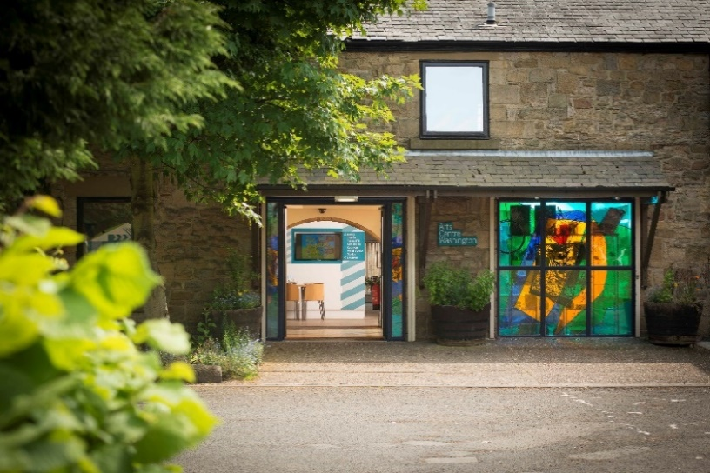
Name: | Helen Green
Position: | Head of Performance for Sunderland Culture
Tel: | 0191 515 5501
Email: | helen.green@sunderlandculture.org.uk

Arts Centre Washington

Artistic Policy
Arts Centre Washington (ACW) is a community hub that seeks to build engagement in the arts primarily amongst the residents of Washington which has some of the lowest levels of engagement in England. A converted farm housing a 120 seat theatre, gallery spaces, recording studio, artists’ studios, art workshop, café bar, rehearsal studios and function / meeting rooms, ACW is a multipurpose arts centre, programming exhibitions, film, comedy and music. Our core priorities are:
- Work for, by and with children and young people
- The support and development of emerging artists, especially those based in Sunderland
- Engaging the community in artistic excellence

There is also a strong current of participation running through everything we do with approximately 75% of visitors to ACW taking part in activities.

ACW seeks to balance programme offered elsewhere in the wider city of Sunderland by concentrating on work that is original, inventive and, of course, small scale. Work that really appeals to us is:
- Performance for children and families
- Performance that has real relevance to local audiences e.g. heritage, armed forces, politics
- Adaptations of well known classics: plays, novels etc
- Performance that involves community participation and amateur dramatics

How we support artists
We provide free rehearsal/R&D space to emerging artists (especially those in the Sunderland area), mentoring and fundraising advice.

We are a member of: NE Exchange – performing artist networking group Venues North.
Spaces & Capacities
Venue |  |  | Capacity
Arts Centre Washington |  |  | 120 (60 if socially distanced)
Seasons
Spring/Summer & Autumn/Winter
How far in advance to contact us
1 year
The kind of financial deals we can offer
Mainly splits and occasional guarantees
We like artists to make initial contact by…
Email only
We prefer artists to contact us
By email | x | By phone |  | By post
Send weblink | x | Send DVD
If you approach us, you can expect…
Owing to capacity we cannot respond personally to every submission. We keep all submissions relevant to each season on file until it is time to programme that season. If we are interested, we will get in touch by email

Programmer’s Contact Details |  | 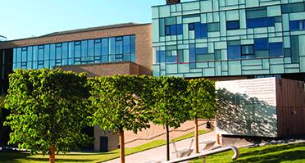
Name: | Ian Morley
Position: | Head of Programming and Artist Development
Tel: | 01226 327000
Email: | ianmorley@barnsleycivic.co.uk

The Civic, Barnsley

Artistic Policy
Who We Are:
The Civic is a small to mid-scale arts centre located in the Centre of Barnsley, South Yorkshire. We programme a varied and dynamic cross section of visual and performance art that includes theatre, dance, circus, comedy, music, community arts, sculpture and fine art exhibitions and a dedicated programme of professional children's theatre.

We believe in collaborative work with companies and organisations and run an annual dedicated artist development programme, CARP (Civic Artists Residency Programme) a flexible programme aiming to support Northern artists in the process of creating work, developing and experimenting with new ideas in a creative and supportive arts environment.

We are a multi-functional and mixed space venue that comprises of The Assembly Room, Gallery@, small rehearsal spaces, meeting rooms and Foyer areas, and Mandela Gardens.

We are an Arts Council National Portfolio Organisation

What are our aims?
Our vision is to provide extra-ordinary art and experiences to the people of Barnsley, Yorkshire and surrounding region. We aim to raise aspirations, challenge perceptions and inspire pride in our community. We aim to achieve this through our dynamic programme

What do we programme?

- Theatre, Circus and Dance
Our Theatre Circus and Dance programme is mixture of contemporary dance, Contemporary Circus new writing, physical theatre, adaptations of classic text and spoken word.

The programme consists of nationally renowned touring companies and local / regional artists. We are predominantly a receiving house but are interested in collaborative and potential commissioning opportunities that have audience development and engagement at their heart. In addition to onsite indoor work, we regularly co-commission and programme work to be presented of site

We programme dance and theatre approximately 10 – 12 months in advance

We are keen to establish dialogue with arts organisations and companies that could support us to engage and develop new audiences.

- Family Performance
We are passionate about programming high quality, dynamic and engaging work for families and young people, we predominantly programme work for 3 – 8 year olds but are keen to explore work that attracts and engages with older children. We work with and programme companies that both adapt classic or known text and with those that produce new writing and devised work. Our family programme consists of fortnightly Sunday afternoon performances, an extended family show for Christmas that is an alternative offer to the traditional pantomime, and periodic longer runs that tie in with school terms and half terms depending on the company and show. We commission and co commission family work and are open to discussions with companies about their work. We programme our family work 6 – 12 months in advance

- Music
Our music programme is a range of touring folk, jazz, blues and classical acoustic artists and bands. We predominantly programme artists producing original material and tend not to present tribute acts as this is already catered for in other venues in the town. However, if available our facilities can be hired for tribute acts. We programme at least one band or artist per month. The music programme is planned 6 – 8 months in advance

- Comedy and Cabaret
Our comedy programme consists of monthly gigs from national touring known comedians and a seasonal showcase of emerging talent in partnership with The Last Laugh Comedy Club. We programme our comedy 6 – 12 months in advance

- Visual Arts
The Gallery@ The Civic currently stages approximately 6-8 temporary exhibitions each year; 3 in the main gallery and 5 on the smaller Panorama space. As The Gallery@ has no permanent collection from which to draw, these exhibitions are a mixture of touring exhibitions from established lenders, exhibitions created specifically for the Civic either by the in-house team or in conjunction with local curators, and exhibitions by local emerging artists and makers. Our aim is to be forward-thinking in our choice of exhibitions, and to present the best of all aspects of art and design to our audience by including a range of contemporary visual fine art, design, fashion, photography and craft. The Gallery@ The Civic is passionate about visual arts and particularly about sharing exceptional and extraordinary visual art with the widest audience. The Civic also believes in nurturing the talent of emerging and established makers, supporting them to create and sell new work, extend their practice and develop
sustainable careers, for example through exhibiting at the venue and through participation in the Civic’s Artistic Residency Programme, CARP.

In addition to Venues North we are members of SVN a Small Venue Network of 20 arts venues in the Yorkshire region that meet and work collaboratively, share knowledge and expertise with the purpose of bolstering the artistic and economic resilience of smaller provincial venues.
How we support artists
We support artists through scratch nights, our CARP scheme, commissions and co-commissions, and rehearsal space
Spaces & capacities
Venue |  |  |  | Capacity
The Assembly Room |  |  |  | 336
Mandela Gardens (outdoor greenspace) |  |  |  | 500
Seasons
2 seasons per year Sept – Jan & Feb – July
How far in advance to contact us
12 – 18 Months
The kind of financial deals we can offer
Varied deals from guarantees to box office splits, first calls, hires
We like artists to make initial contact by…
Email followed by telephone
We prefer artists to contact us
By email | x | By phone |  | x | By post
Send weblink |  | Send DVD
If you approach us, you can expect…
I will aim to respond with 2 weeks

Programmer’s Contact Details |  | 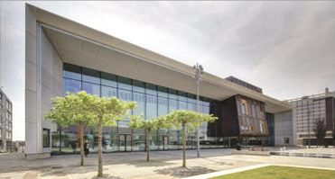
Name: | TBC
Position: | Associate Producer
Tel: | 01302 303 950
Email: | programming@castindoncaster.com

Cast, Doncaster

Artistic Policy
Cast’s mission is to enrich the creative and culture life of our communities through high-quality artistic experiences. We aim to raise engagement in the arts in Doncaster through a varied performance programme; to raise aspiration and develop cultural capital through participation in creative activity. We work in partnership using the arts as a powerful tool for social change and place making.

Cast’s artistic programme spans a number of spaces and includes both indoor, outdoor and digital work. We mainly programme touring product in our spaces, alongside community work, hires, and work that we co-produce and/or co-commission. We have a thriving artist development programme with a range of different strands.
How we support artists
We have an Associate Artist scheme (currently 5 companies), and we also support a range of other artists and emerging companies through mentoring, signposting, R&D time in our spaces and a small amount of commissioning funds. We run monthly artist hangouts and support a writers’ group and offer masterclasses and workshops. We also have an emerging community company of citizen artists who have opportunities to perform at Cast.
Spaces & Capacities
Venue |  |  |  | Capacity
Main House |  |  |  | 620
Second Space |  |  |  | 142
Seasons
Seasons: Feb – July, Sept – Nov
How far in advance to contact us
6-12 months
We aren’t interested in booking…
Hypnotists, wrestling, mediums
The kind of financial deals we can offer
Mainly box office splits, occasionally work on first calls for studio shows, some guarantees in the main house
We like artists to make initial contact by…
Make contact initially by email please
We prefer artists to contact us
By email | x | By phone |  |  | By post
Send weblink |  | Send DVD
If you approach us, you can expect…
Programming tends to happen in clusters where a range of potential work is considered, so we can’t always respond immediately.

A “no” this time doesn’t mean that we aren’t interested in future work!

Unfortunately, it is impossible to reply to everyone with detailed feedback on shows and due to the number of proposals we receive, we tend to only respond to artists/companies who we have a relationship with or whose work we wish to discuss further. If we haven’t responded within 3 months, it will usually mean that we haven’t been able to include your work on this occasion.

Please include your touring plans and if we aren’t able to programme your show, do let us know when it is touring.

We try and see work where possible, but it is helpful if you are able to share your work/showcase/clips digitally with us.

Programmer’s Contact Details |  | 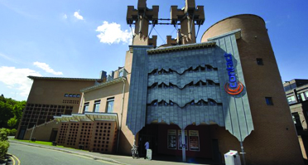
Name: | Ric Watts
Position: | Programme Manager
Tel: | 0161 274 06 11
Email: | ricwatts@contactmcr.com

Contact, Manchester

Artistic Policy
Contact is where young people change their lives through the arts, and audiences of all ages experience exciting and diverse new shows. It is the leading national theatre and arts venue to place young people at the decision- making heart of everything: where young people aged 13-30 work alongside staff in deciding the artistic programme, making all staff appointments and act as full Board members. The result is an outstanding, diverse and accessible artistic programme for everyone.
We present contemporary theatre, dance, live art, cabaret, spoken word, circus, comedy and music. We support artists who work across any or all of these art-forms, or who are inventing new forms. We have a particular interest in work that speaks to people under 30, that is socially engaged or that young people find exciting and relevant.
Our programme features:
- Professional shows produced or commissioned by Contact (including a strand of work which is health, wellbeing or science focused)
- Contact Young Company shows, made in collaboration with leading artists
- Touring shows selected by young people and staff
How we support artists
The information provided is correct as of November 2021, however in the first half of 2022 we will start working with a new Artistic Director. As such, our focus and programmes of work is subject to evolve. For the most up to date information, please see our website.
Based in our unique creative building in Manchester, we provide a range of support programmes for artists of all career stages, and emerging arts leaders. An ecology under one roof, Contact supports artists across live performance forms (theatre, dance, spoken word, music, cabaret, live art and comedy) progressing from youth programmes to professional development for artists from across Greater Manchester and the UK. Support takes the form of emerging artist commissions, artists labs and development schemes, and major productions and co-productions for national touring:
Co-productions and Main House artist commissions
As well as in-house productions and co-productions, Contact commissions several shows a year; this includes 3 commissions up to £1,500, for emerging artists who are alumni of Contact to conduct initial research phases, and mid- / large-scale productions, and co-productions (between £8,000- £20,000). Co-productions and Contact productions are developed and presented at Contact before extensive national touring, and several have recently been subsequently developed for BBCTV. Shows often have a particular focus on socially engaged practice, work that platforms under-represented communities and narratives, or that has particular interest to young people under 30.
Health and Science Commissions
Contact annually commissions around 4 artists/companies to develop new work exploring health inequalities or research with a range of partners (Wellcome, Public Health England). From 2020 these will be developed in our Wellcome funded Space 0 supported by our Health and Science Producer Chloe Courtney.
Contact Young Company (CYC)
An annually recruited ensemble of 25 young artists aged 15-25. CYC undergo a year-round programme of weekly workshops, see shows in our programme, and join subsidised places at Contact masterclasses. CYC make 3 professional-standard shows in collaboration with leading artists for professional contexts, including touring recently to Southbank Centre, Traverse Theatre and BAC. Form/scale and location varies during the programme (promenade, studio pieces, mid-scale shows, work for families).
Director Development
Director support takes the form of paid opportunities to shadow and assist professional directors and companies working on Contact Young Company shows and in-house productions, with considerable responsibility to work with lead artists throughout production. Contact also appoint and support emerging directors to lead on specific projects.
Young Musicians
Funded by Youth Music, we provide weekly training in music, media and production at drop-in level (Music Drop) through to professional activity (Level Up) aimed at producing skilled musicians, vocalists and MCs able to develop their career in the music industry. A strong focus on diversity and gender balance has created a highly distinctive offer in the city, with the monthly Monday Mic Night providing a public showcase for artists.
The Agency
The Agency is a youth enterprise project that works with young people from marginalized areas to create social enterprises, events, projects and businesses that will have a positive impact on their local communities. It uses a creative methodology developed in the Favelas of Rio De Janeiro.
We have also historically run a number of talent development schemes including Re:CON (young programmers and producers team), Future Fires (young community arts practitioner programme) and Technique (training programme for emerging technicians and production managers). These programmes are being redeveloped and relaunched for 2022 now we are back in our building following capital redevelopment.
Spaces & Capacities
Venue |  |  |  | Capacity
Main Space (Space 1) |  |  |  | 320
Studio Space (Space 2) |  |  |  | 70
Space 0 (Science and Health focused space, in partnership with Wellcome Trust) |  |  |  | 50 seated, up to 100 standing.
Seasons
Sep to Jan, Feb to May, with Queer Contact Festival in February and off-site projects over the summer
How far in advance to contact us
For touring work at least 6-12 months in advance. For commissioning/co-production partnerships ideally at the start of the project.
We programme two main public seasons: Feb to May and Sept to Jan, around 6-12 months in advance. The Programming team meet fortnightly to discuss submissions from artists and companies. When selecting work we consider carefully how they meet our programming aims as well as how they fit our spaces, budget and overall programme ethos.
We aren’t interested in booking…
We do not programme traditional adaptation of classical texts. We do not accept unsolicited texts.
The kind of financial deals we can offer
Fees are negotiated though we aim to provide guaranteed fees rather than splits. We are also open to proposals from artists, companies and organisations for commissioning/co-production opportunities, through cash contributions and in-kind support. We also co-present with other venues in the city.
We like artists to make initial contact by…
We welcome submissions from all artists and companies. If you would like your work to be considered for inclusion in Contact’s programme please email a proposal to programming@contactmcr.com

You should include the following information:
- Who you are and what kind of work you make
- Contact details including a current mobile number
- Details of the project including video footage, script, press reviews and information about the creative team.
- An invitation to see the work or other work by the same company/artists.
- Which space at Contact the work will fit in and why Contact is the right platform for your work.
We prefer artists to contact us
By email | x | By phone |  |  | By post
Send weblink | x | Send DVD
If you approach us, you can expect…
Once you have contacted us, if we are interested and excited by your submission or require further information, we will get in touch initially by email or phone. Please note that we receive a high number of programming submissions each week, and it may take some time to respond to emails. If we have not responded within 6 weeks, it is unlikely that we will be pursuing your submission for inclusion in our programme.

Programmer’s Contact Details |  | 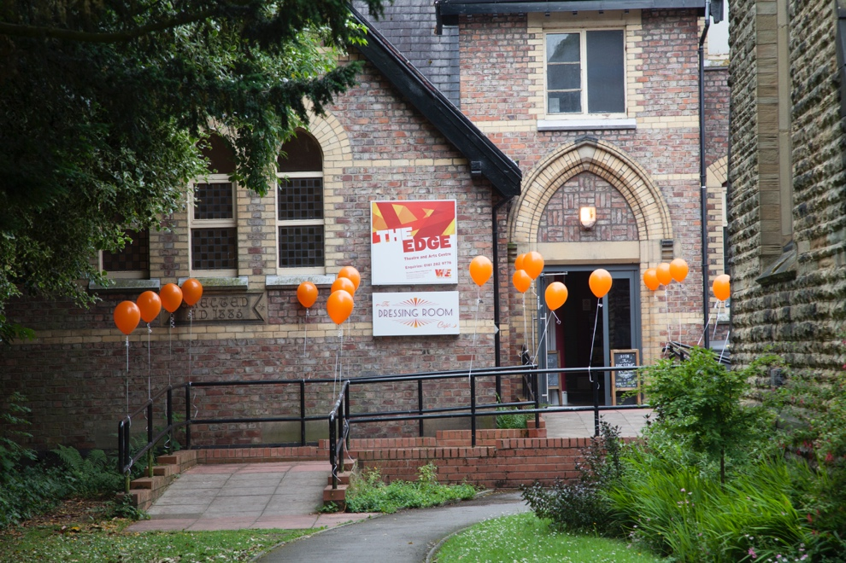
Name: | Janine Waters
Position: | Artistic Director
Tel: | 0161 2829776
Email: | Janine@edgetheatre.co.uk

The Edge Theatre & Arts Centre

Artistic Policy
We programme small or mid-scale touring theatre, new writing, children’s work, music, dance, comedy and spoken word.
How we support artists
Each year we work with 2 early and mid-career Manchester based companies to create a new piece of work, as part of our Made at The Edge scheme. This can be through free rehearsal space, artistic direction or scratch nights
Spaces & Capacities
Venue |  | Capacity
Theatre |  | 62-102
Seasons
Jan – Apr (Spring)
May – Jul (Summer)
Sept – Dec (Autumn)
How far in advance to contact us
6-12 months
We aren’t interested in booking…
No arts events, tribute bands, mediums, clairvoyants
The kind of financial deals we can offer
Usually, a 70/30 split

We like artists to make initial contact by…
Email with programming in the subject line, telling us a bit about yourself, your work and why you think it would work well at The Edge.
We prefer artists to contact us
By email | x | By phone |  | By post
Send weblink | x | Send DVD
If you approach us, you can expect…
Emails to Janine@edgetheatre.co.uk about programming will be looked at and, if of interest, responded to within 12 weeks. Unfortunately, we cannot respond to all the emails that come through to this account due to the high level of proposals we receive.

Programmer’s Contact Details |  | 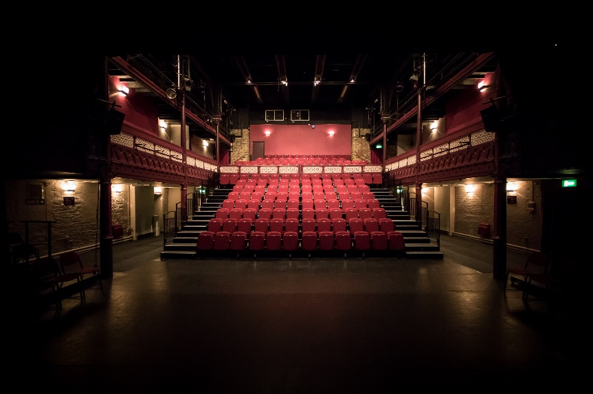
Name: | Porl Cooper / Nick Hopwood
Position: | Programmer / Head of Performance Venues
Tel: | 0114 222 8889
Email: | enableus@sheffield.ac.uk  n.hopwood@sheffield.ac.uk

Enable Us – University of Sheffield

Artistic Policy
Established in 2017, Enable US (a University of Sheffield Performance Venues initiative) is a two-week festival of high-quality new theatre and touring performance presented each Spring & Autumn at University of Sheffield Drama Studio. It provides a platform within the University of Sheffield Performance Venues to bring audiences, artists and the University community together to experience, inspire and be inspired by performances that stimulate thought and broaden understanding, as well as providing access to workshops, training and development.

In our twice yearly Enable US Festivals, we are enabling new and innovative performing arts companies to perform in Sheffield, companies that may not have previously had a platform to present their work in the city. The Enable US Festivals take place at the Drama Studio for two weeks in Spring and two weeks in Autumn. They attract a growing audience from Sheffield and beyond to enjoy performances that are new, inspiring, and exciting.

Our artistic programme encourages opportunities for students at the University of Sheffield to work alongside professional arts practitioners, to develop their own creativity and to grow as individuals. We also aim to develop work-based learning programmes and internships within the cultural and creative professions.

We Actively seek work with themes and topics which resonate across Faculties and Schools (beyond School of English), a full list of which can be found here:
https://www.sheffield.ac.uk/departments/faculty-departments

Within that remit, we will prioritise:
- International Work
- Physical Theatre, Dance & Circus
- Work by midcareer artists (to balance the other local venues focus on the New and Emerging)
How we support artists
Single night programmed performances within the Enable US festival period.
Resident Company opportunities, following annual call out, giving access to year-round rehearsal space, technical facilities, plus cash support, and brokered relationships with academics, schools, and faculties within the University, which may then inform the work being made.
Spaces & Capacities
Venue |  |  |  | Capacity
Drama Studio (main home of EnableUs programme) |  |  |  | 177 seats, flexible formats
The Octagon |  |  |  | up to 1230 seats,1600 standing, flexible formats
Firth Hall (concert venue) |  |  |  | 380 seats
Seasons
2 weeks in the Spring (between Feb and April) and 2 weeks in the Autumn (between Oct and Dec) with occasional dates outside of this which can be included in our 6 monthly brochure
How far in advance to contact us
As early as possible, but ideally 6-9 months in advance. We can consider productions in the short term under certain circumstances.
We aren’t interested in booking…
Work that has already been presented in the region (as we have limited no. of performance slots) or will be presented at other venues in South Yorkshire in the same period. Otherwise, all approaches are considered.
We are always interested in work which resonates with the University Faculties
(List here https://www.sheffield.ac.uk/departments/faculty-departments) and that which has a specific interest to encourage engagement between the company, students, academics, and the local community
The kind of financial deals we can offer
All deals are negotiated
Guaranteed fees / fees vs splits (in line with the potential yield of the space!) are met subject to secured external funding. EnableUS does not (currently) work on a financial model with university subsidy as many other university venues may do.
First Calls or splits can be offered otherwise.
We like artists to make initial contact by…
E-mail
Please try and include as much of the following information;
• Mobile number
• An invitation to see work
• Information about the work, press reviews, background info about the creative team
• Information of where the work has previously been presented
• Potential tour dates
We prefer artists to contact us
By email | x | By phone |  |  | By post
Send weblink | x | Send DVD
If you approach us, you can expect…
A response within 14 days to tell them whether their dates or production fit into our programme or if we may be interested in future productions

Programmer’s Contact Details |  | 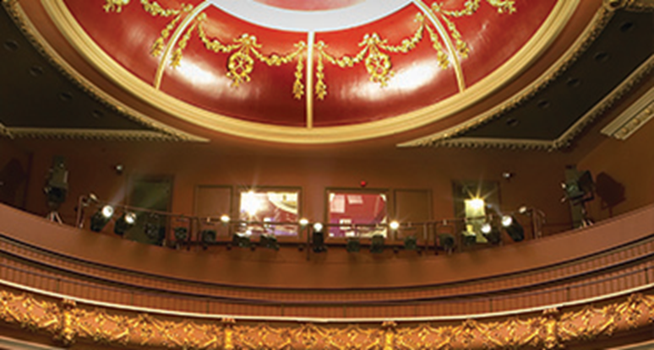
Name: | Porl Cooper
Position: | Programmer
Tel: | 01423 502710
Email: | Porl.cooper@harrogatetheatre.co.uk

Harrogate Theatre

Artistic Policy
Harrogate Theatre has two performance spaces (a main auditorium that seats 500 and a studio space that seats 60), which allow for producing and presenting theatre, dance, music and comedy. It is also home to a number of community groups that regularly perform musicals and plays throughout the year. The organisation also runs a vibrant education and outreach department that delivers throughout the District from an adjacent building called Hive. The Theatre has undergone considerable artistic development in the past 10 years that has seen the organisation establish itself as a significant influence in the region, with a growing national profile.

Over the past three years the Trust has acquired programming responsibilities for a programme of live events at the Royal Hall (1,000 seats) and Harrogate International Centre (2,000 seats), allowing for internationally renowned companies and artists to be part of the eclectic artistic programme.

Our Mission Statement is as follows:
Harrogate Theatres produce and present a programme of quality drama, dance, comedy, music and festivals that celebrate the diversity and richness of British and world cultures, whilst identifying opportunities to work closely with artists and practitioners that challenge and excite audiences.

Harrogate Theatres works with all stakeholders to generate educational activities that encourage an appreciation of the arts as participants or audience members. Harrogate Theatres acknowledge that activity within the arts sector contributes to the buoyancy of the local economy and therefore seeks to collaborate with other venues, cultural providers, funders and business partners.
How we support artists
Harrogate’s support for new work and artists takes three main forms.
- Scheduling / programming work as part of the main programme (we should be able to see the work in advance elsewhere or as a recording OR the work should come endorsed by at least one other venue programmer who has seen the work themselves).
- Ongoing affordable sometimes free workshops, masterclasses and learning sessions for creatives from anywhere throughout the year.
- 4 annual seed commissions, which since 2020 have taken on a new approach, to try to make the process as fair as possible and to allocate our available funds as equally as possible. Each year will have a call out (via the venue’s Social Network channels among other places) for 4 opportunities of seed funding, space, support in kind and up to a week of performances. We will select 3 companies that are “known to us” (either through previous support or simply programming previous work) and 1 company completely “unknown to us” but whom we would prefer to be based or creating work within the Venues North footprint. The call outs will usually contain a specific provocation. One year it might be “how does your project meet the Creative Case for Diversity”, another year it might be “How does your project aim to engage XXXXXX (audience demograph)”. Successful applicants are selected by a panel of 4 and not just one programmer. There are no strict criteria for who we work with but our priority is to ensure that we work with the most varied selection of companies as our resources allow and those hailing from the North of England, and Harrogate and District / North Yorkshire in particular. We actively encourage companies to make the work with us and have ongoing dialogues with all departments through that process.

Additionally, Rehearsal space is available across the year or at a very heavily subsidised rate.
There are bookable ‘Surgeries’ available with the Associate Producer across the year.
Please note that both our rehearsal space and studio performance space are not in step free spaces
(our building is 120 years old) and we currently do not have a lift to either space. We are doing our best to remedy this and, in the meantime, continue to develop relationships with other more accessible spaces for performance and rehearsal.

We welcome proposals for work that can present in offsite step free and low tech spaces.
Spaces & Capacities
Venue |  |  |  | Capacity
Main House |  |  |  | 500
Studio |  |  |  | 60
Offsite Spaces |  |  |  | Various 50--200
Royal Hall |  |  |  | 1000
Seasons
Jan – April (late Oct Deadline)
May – July (late Feb deadline)
Sept – Dec (early Jun deadline)
How far in advance to contact us
Any time before the above brochure deadlines
We aren’t interested in booking…
Clairvoyants. We have a strong amateur programme of musicals and some dramas, so we always have to be aware of the balance of work across the venues. We wouldn’t look for Studio scale classical drama, and generally prefer new work to established texts
The kind of financial deals we can offer
Please do acknowledge that the studio size is only 60 seats and we can only consider deals and financial requests that can work within the potential yield of its capacity! (i.e. please avoid emailing to say that your work is “perfect for (y)our studio” whilst also telling me it comes with a £1200 price tag!)

For studio touring work we can offer a baseline or modest GT against 70%.

For main house work, GT’s vs splits are preferable.

Where you are absolutely convinced “the show will sell out” we will happily take your super confident hire money (at a very reasonable rate!)
We like artists to make initial contact by…
Email
We prefer artists to contact us
By email | x | By phone |  |  | By post
Send weblink |  | Send DVD
If you approach us, you can expect…
We will try to respond to enquiries ASAP, given part time roles. As of Dec 2020, there is no full-time programmer.

To help with the volume of enquiries combined with the part time hours, there is an auto reply on the that gives an update as to where we are with programming, and hopefully some other helpful pointers, but does say that if you don’t hear back in a certain timeline, please assume that the work is not a good fit for us right now. (Often helpfully saying “sorry, no” can be as time consuming as pulling together the programme, so we have found this auto response to be useful and artists have acknowledged its helpfulness.

Programmer’s Contact Details |  | 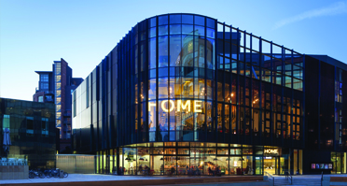
Name: | Kevin Jamieson
Position: | Head of Programme
Tel: | 0161 212 3476
Email: | Kevin.jamieson@homemcr.org

HOME, Manchester

Artistic Policy
We work with artists to produce questioning and ambitious artistic projects and involve audiences with new and extraordinary theatrical experiences. We programme an exciting, eclectic mix of plays, and our focus is celebrating and commissioning artists with a unique theatrical language. Sitting so closely to the best of international, independent cinema and contemporary visual art has inspired us to have strong visual ambitions for all our work in the theatre.
Theatre at HOME has an international focus. We are a home for UK premieres of foreign language plays and celebrate many of the most inventive international theatre companies making work around the globe. Our annual ¡Viva! festival (April) joins together with our partner art forms in a venue-wide exploration of film, theatre and visual art from across the Spanish-speaking world. Dance theatre, combining the raw emotion of dance with the narrative of theatre also has a new home in Manchester and we are working with international partners to commission and produce bold new work as well as host the best touring productions in this exciting medium.
Theatre 2 was launched in 2016 with a desire to explore the world around us through the lenses of the most exciting local, national and international companies. These companies are playful, questioning and challenging sharing unique viewpoints through daring performance practise. Orbit (October) is Theatre 2’s annual showcase festival and brings together a collective of artists and performances from some of the world’s best festivals as well as premiere productions into a two-week celebration.
We continue to work with the best of Manchester’s thriving fringe scene with our Bi-annual PUSH Festival (January), which is dedicated to supporting emerging artists, filmmakers, and theatre makers to help them to develop, promote and showcase their practice.
We also have a focus on developing the work and careers of emerging and mid-career theatre makers. A programme of encounters, events and workshops – many led by visiting practitioners of national and international standing – will provide the support, insight and platform needed to allow theatre’s next generation to flourish.

How we support artists
We want HOME to be a creative hub for the region, where local and world-class talent of all backgrounds and disciplines are discovered, nurtured and showcased, and come together to create new experiences, Emerging creatives can take advantage of one-off skills workshops, long-term development residencies, commissions and regular showcase opportunities, which support the professional development of theatre makers, visual artists and filmmakers at all career stages and connect our region’s creatives with national and international practitioners making work for our stages, screens and galleries.
HOME work on talent development across all five strands of the programme; visual art, film, theatre, community and young people, digital and creative. Throughout the year we run a number of specialist skills workshops, masterclasses and in-depth projects to support the professional development of artists at varying career stages. This varied programme aims to connect regional artists with practitioners/companies making work for our stages, screens and galleries.
Projects include;
Talent Development Surgeries
Do you want to discuss a project idea, need a bit of career advice or would like to find out more about the Talent Development opportunities here at HOME?
Our producer surgeries are a chance to book in 30-minute chats with one of our Talent Development producers. We can’t promise that we’ll have all the answers, but it will be a chance to discuss whatever you’re working on, get some feedback from an industry professional and find out more about all the opportunities at HOME.
Explore
This opportunity is designed to be the most flexible, light touch way of supporting an idea or project to get off the ground. This can be used for both professional development and research opportunities. This fund provides seed funding (up to £500) with access to development space alongside support from Talent Development producing team.
Develop
This opportunity is designed for artists who are ready to experiment further with an idea or project in a deeper way.
Each year we are committed to up to four Develop opportunities which each offer financial support (up to £2,000), dedicated development space and bespoke mentoring from our creative team. At the end of each opportunity there will be a chance to share and discuss the work with our team.
Mothers Who Make
Mothers who Make is a growing national network aimed at supporting mothers who are artists, working in any discipline and at any stage of their careers. It is a peer support group and creative exchange session for mothers who are artists – professional and/or passionate – writers, painters, actors, dancers, filmmakers, photographers…every kind of maker welcome, and every kind of mother. Please feel free to bring along your children, of any age, whether they are inside you, beside you or running round the room!
PUSH Festival (January)
PUSH is HOME's bi-annual festival dedicated to supporting emerging North West-based creatives to develop, promote and showcase their practice and create new networks. It’s no secret that Manchester is a creative jewel of a city, brimming with theatre-makers, filmmakers and visual artists pushing the boundaries of the way we make and perceive work. PUSH shines a light on that local talent and provides a platform for creatives from all art forms to showcase work that thrills, excites and challenges audiences. PUSH also aims to provide creatives with the skills to develop and push their practice further so expect workshops, panel discussions and networking opportunities.
PUSH Lab (January)
For artists of all disciplines, PUSH LAB is a week-long programme of conversations, events, and workshops to inspire, provoke and challenge your thoughts of making work in 2022 and beyond. We also hope that it will be a chance to recharge and reconnect.
There will be opportunities to meet other artists, debate important issues, learn new skills or ways of working, and have fun in the process.
ORBIT (October)
Our annual Orbit festival showcases some of the most exciting and critically acclaimed productions from the Edinburgh Fringe Festival and beyond. In tandem with the diverse programme of shows, visiting companies and artists deliver a range of open access workshops for local theatre makers.
To be kept informed of upcoming opportunities and events please sign up to our Creative Opportunities Newsletter https://homemcr.org/about/work/talent-development/
HOME is also part of the GM Artist Hub offering support to the independent practitioners, artists, and companies of Greater Manchester. You can find out more and sign up for a free 30-minute Advisory Session on the https://www.gm-artisthub.co.uk/

Spaces & Capacities
Venue | Capacity
Theatre 1 | 450 seats
Theatre 2 | 130 seats
Plus 5 cinemas and 2 Galleries
Seasons
Sept – Feb
Mar – Aug
How far in advance to contact us
For all theatre 12-18 months. We always like to hear from artists at the earliest stages of their development so we have the opportunity to watch any work in progress or scratch sharing’s that may be planned. This way we get a very good send of the work and the artist.

We aren’t interested in booking…
We do not hire our spaces out to companies and all work must be curated by HOME
The kind of financial deals we can offer
We work on a variety of deals which we will discuss with the artist and will change on a show-by-show basis. We look for deals that make most sense to the artist/company and their needs.
We like artists to make initial contact by…
Email
We prefer artists to contact us
By email | x | By phone |  | By post
Send weblink | x | Send DVD
If you approach us, you can expect…
Any personalised emails will always be answered and if shows are of interest they will be held on file. If the email is not personalised and the show is not of interest for HOME then we will not reply.

Programmer’s Contact Details |  | 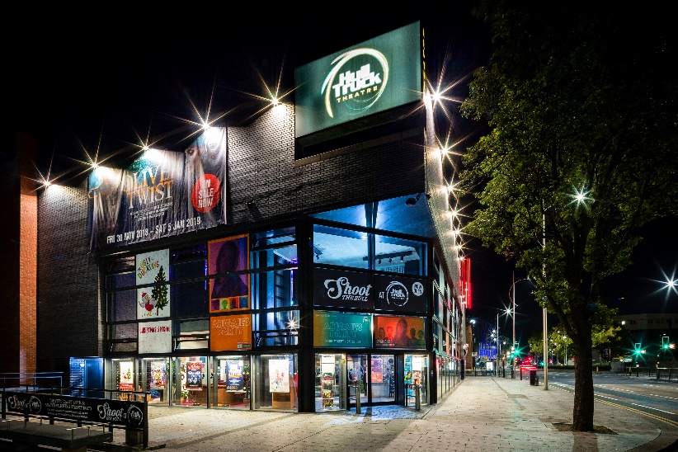
Name: | Adam Pownall
Position | Senior Producer
Tel: | 01482 488 244
Email: | programming@hulltruck.co.uk

Hull Truck Theatre

Artistic Policy
Hull Truck Theatre is the flagship venue for Hull and the surrounding region presenting a theatre-led, mixed-disciplinary programme of produced and visiting work. We are a pioneering theatre with a unique Northern Voice, locally rooted, global in outlook, inspiring artists, audiences and communities to reach their greatest potential.
We are excited by work that is imaginative, compelling and reflects the diversity of a modern Britain through a focus on stories and people. We aim to present exceptional work across a broad range of theatrical forms and styles, to delight and inspire our wide range of audiences.
The values which underpin our programme are: Innovation; Inclusion and Integrity.
The Heron
Drama is at the heart of our programming, and we have relationships with a number of key touring partners whose work we programme on a regular basis, including Northern Broadsides, The John Godber Company and Hull Jazz Festival.
Dance, music and comedy are programmed across both spaces and, as with the drama programme, we curate and promote work by companies of national repute.
Studio Theatre
Our Studio is a space for new and sometimes more challenging theatrical experiences. We are particularly interested in exploring the idea of a ‘Northern voice’, and of increasing the depth of our relationship (and that of our audiences) with artists making theatre in the North through supporting the creative development of work. The Studio is also a fully equipped cinema and we present a programme of live stream broadcasts and independent films with partners such as the Royal Shakespeare Company and Hull Independent Cinema.
How We Programme
We are committed to presenting work that reflects the diverse communities and artists that populate our nation. We will not book work that does not meet the overall values of the theatre or that does not reflect the diversity and inclusion of a modern Britain.
We focus on the following strands to deliver thrilling and vital work that speaks of today:
- Good Fit
This is the broadest of our strands, incorporating performances that make a good night out for diverse audiences and including everything from classical drama to jazz and stand-up comedy.

- Innovative
Our primary focus for our visiting studio programme will be on developing and showcasing the work of contemporary UK artists and widening the pool of Northern based artists.
Through our partnerships with Venues North and artist networks, we will programme a diverse range of work from new writing from well established companies such as Graeae, Eclipse, Paines Plough, Sherman Theatre Cymru to spoken word, comedy and contemporary dance and circus.
- Local to Hull & East YorkshireAs the largest producing theatre in Hull & East Yorkshire, we aim to represent and nurture the talent and experience local to Hull Truck Theatre. This work will either be made in Hull & East Yorkshire or have a clear link to the region (individual artists, stories that resonate etc).

- Children & Family
We look to programme a broad range of work for families and children, from well-known titles to innovate and contemporary storytelling.
How We Support Artists
Grow is our year-round artist development scheme for artists and companies at all stages of their career. Alongside a structured Supported Artists and actor training programme (the Regional Young Actors Ensemble) we provide artistic residencies through Be Our Guest, which provides artists with rehearsal space, accommodation, mentoring support and £1000. We also host our regular scratch night, First Time Out, which include structured feedback sessions. In May we host our annual Grow Festival, which consists of workshops, conversations, performances of new work and creative networking opportunities. Applications for residencies, scratch nights and other opportunities are advertised on our website
Spaces & Capacities
Venue |  |  |  | Capacity
Main Theatre |  |  |  | 429
Studio Theatre |  |  |  | 135
Seasons
Jan – Jul, Sep - Dec
How far in advance to contact us
6 - 12 months
We aren’t interested in booking…
We will not book work that does not meet the overall values of the theatre or that does not reflect the diversity and inclusion of a modern Britain.
The kind of financial deals we can offer
Both spaces work mainly on a 70/30 box office split in the visiting company’s favour; however, we do a variety of deals dependent on the show, our audience forecast and our relationship with the artist or company.
We like artists to make initial contact by…
If the show is tour-ready, please send a tour pack to programming@hulltruck.co.uk with copy, images, reviews, and an indication of who the work is for.

Please do not send a script or DVD unless requested.

Please do be clear about how you think your work fits into one (or more) of the first three programming strands. If the show is in development, please introduce yourself and your work and tell us why you are interested in working with Hull Truck Theatre and what your work offers our audiences.

Let us know where and when we can see your work, and which other industry partners you are working with.

We rarely programme work by artists whose work we are not familiar with, so invitations to festivals, showcases and scratch performances in advance of tour booking are welcome.
We also take recommendations from industry colleagues.
We prefer artists to contact us
By email | x | By phone |  |  | By post
Send weblink |  | Send DVD
If you approach us, you can expect…
The programming email account is checked regularly, but due to the volume of proposals received it is not possible to respond to all. All proposals are kept on file until we are ready to programme: we hold programming meetings every couple of months and discuss as many proposals we’ve received as possible. We will get in touch with you if we think the show may be a good fit for us and are interested in exploring further. We try to see as much work as possible, so invites are always welcome. If you are coming to Hull Truck Theatre to see a show, please let us know and we will try to say hello in person.

Programmer’s Contact Details |  | 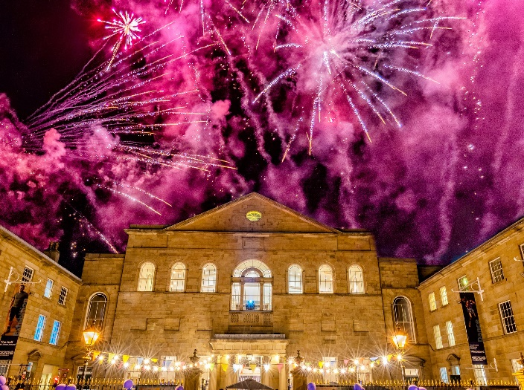
Name: | Henry Filloux - Bennett
Position: | CEO
Tel: | 01484 430528
Email: | programming@thelbt.org

Lawrence Batley Theatre, Huddersfield

Artistic Policy
We are a mid-scale theatre in the heart of West Yorkshire, housed in a recently refurbished Grade II* listed building which was once the largest Wesleyan mission in the country. Within the building there are four performance spaces – the Main Auditorium seating 461 people, the Cellar Theatre with up to 120 seats, the Attic Theatre with up to 60 seats and a large Courtyard, to the front of the building, perfect for outdoor performances. The theatre also has two meeting rooms and a Gallery space.

We are primarily a receiving house – with a mix of drama, contemporary dance, music, comedy, film and family work – but we also produce and commission work. Over the pandemic we were at the forefront of digital innovation working in partnership with other regional theatres to create critically acclaimed digital performances seen by over 70,000 people worldwide. In 2022 we will co-commission three world premieres and stage our sixth annual pantomime. We have a longstanding and incredibly positive relationship with a number of exceptional amateur companies who regularly perform at the Lawrence Batley Theatre. Participation is absolutely at the heart of the organisation, and we do a huge amount of work both on site and across Kirklees more widely – all of this is seen through a lens of tackling isolation, building communities and creating a place of belonging.
How we support artists
Primarily we are able to support artists through our talent development programme, focussing on new writing and northern creatives. Also, through performance and rehearsal spaces in our beautiful building. More details can be found on the website (thelbt.org).
Spaces & Capacities
Venue | Capacity
Main House | 461
Cellar | 120
Courtyard | 100
Attic Theatre | 60

Seasons
We have two brochures which typically land in November (covering December to August) and June (covering July to December).
How far in advance to contact us
As far in advance as possible please.
We aren’t interested in booking…
The kind of financial deals we can offer
We tend to offer splits but can offer first calls on some work and guarantees on a very small number of shows depending on their scale and profile.
We like artists to make initial contact by…
By email (programming@thelbt.org). Please introduce yourself and your work and tell us why you are interested in working with the Lawrence Batley Theatre, how your work fits into our programme and what it offers our audiences. Let us know when and where we can see your work and how we can find out more about what you do. There may be a delay in any response as we programme in batches.

We also attend festivals and showcases, meet artists, listen to recommendations from other professionals and go and see performances to help us identify people with whom we want to work.
We prefer artists to contact us
By email | x | By phone |  | By post | x
Send weblink | x | Send DVD | x
If you approach us, you can expect…
A fast and supportive response.

Programmer’s Contact Details |  | 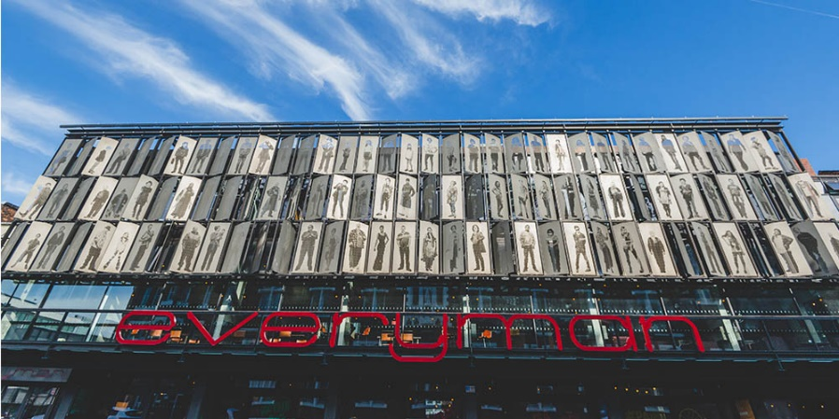
Name: | Ashlie Nelson
Position: | Programmer
Tel: | 0151 708 3704
Email: | a.nelson@everymanplayhouse.com

The Liverpool Everyman and Playhouse

Artistic Policy
The Liverpool Everyman and Playhouse’s mission is to inspire our city and reflect our community. We believe in change-making, socially impactful theatre that is representative of the North West. Across our two spaces we seek to program and produce work that Liverpool wants to see and to harness the power of theatre for good.

We love creative, inspiring, and relevant theatre that speaks to diverse, contemporary Liverpool. We actively seek out new work from North West artists with embedded talent development a vital touchstone of what we do.
How we support artists
YEP
Our dedicated Young Everyman Playhouse department (YEP) provides opportunities for young people aged 14-25, no matter their circumstances. There are six strands to YEP; actors, directors, marketers, producers, technicians and writers. Programs run at a minimum of one year up to five (actors) and all members of YEP get access to £5 show tickets and free access to pre-show events and workshops.

Playwrights Programme
Each year, up to ten writers are invited to join our completely free Playwrights' Programme and work closely with our New Works Associate to hone their playwriting skills and knowledge.
The programme invites writers to explore the fundamentals of playwriting through a series of fortnightly workshops led by the New Works team, visiting writers, directors and other practitioners.

The group receives a reading list, with access to our extensive script library and free tickets to all our in-house productions. There are also supported opportunities to share work in table reads and Scratch Studio.

The group sessions run in two terms: October to December and January to April. The programme meet fortnight on Thursday evenings between 6pm and 8.30pm. Applications open in July.

New Works
Our New Works department work with supported artists offering tailored support and mentorship. This includes script notes, seed commissions, block-booked rehearsal space, RnD time, mentoring, supported sharings and table reads as well as custom events such as Bistro takeovers for cabaret artists and pop-up collaborations. We also program new work and host residencies from Liverpool artists in our Playhouse Studio. We try to start from a place of ‘what can we do to help’ and be responsive to artist needs.

The best route for becoming a supported artists is to let us get to know you. Invite us to your work
through the newworks@everymanplayhouse.com address, send us something to read or take part in a Scratch Studio. Please note that supported artists and companies must be based in or originate from Merseyside.

Script Submissions
Our New Works department accept unsolicited script submissions from writers originally from or based in the North West. Please email your script to newworks@everymanplayhouse.com with an accompanying script submission form that can be found on our website.

Scratch Studio
Our monthly Scratch Studio session sees emerging creatives based in Liverpool share 10 to 15 minute extracts of work in progress and get feedback from the audience in a facilitated discussion. Tickets to Scratch studio cost £5 and include a coffee and a pastry. To submit something to a Scratch Studio email scratch@everymanplayhouse.com telling us a little about your work to date and a brief outline of what you'd like to share

Spare Room
The Everyman and Playhouse offer free rehearsal space to local companies and individuals depending on availability on a week-by-week basis. If you require a room or wish to register as a user for future instances, for rehearsals please get in touch at newworks@everymanplayhouse.com with Spare Room in your subject line. Please note that space cannot be block booked and is only to be used for none commercial activities (e.g., no paid for courses or workshops).

The Writers Room
The Writers' Room is a quiet, free space to escape to and work on your current play or dip into our extensive script library. You can bring your own laptop or book in advance to use one of our two desktop computers. The Writers’ Room is open from 10am-10pm Mon – Sat apart from when in use by Playwriting courses.
Spaces & Capacities
Venue |  |  |  | Capacity
Everyman – thrust stage |  |  |  | 405
Playhouse – proscenium end on |  |  |  | 650
Playhouse studio – black box, thrust |  |  |  | 70
Seasons
Spring – Jan – June
Autumn/Winter – Sept – Dec

We have ‘on sale’ windows throughout the year and don’t work towards two season announcement deadlines.
How far in advance to contact us
We are interested in hearing from artists all year round. If you would like us to come and see your work, we require two weeks’ notice for shows in the Liverpool region and at least three for those outside of it.

If you are making a programming or touring enquiry then we require 6 to 12 months lead in.
We aren’t interested in booking…
We will not book work that does not speak to contemporary Liverpool or that does not reflect our core values of relevance, courage and compassion. We are also not interested in work that does not represent the diverse make-up of Liverpool communities.

We usually only programme work by Liverpool and Merseyside-based artists and companies into our studio space, so it’s unlikely that we can take touring studio scale work.
The kind of financial deals we can offer
All deals are negotiated and include box office splits and guarantees. We do not hire out our performance spaces for shows although we do offer commercial hires for other events such as weddings and talks.
We like artists to make initial contact by…
Email
We prefer artists to contact us
By email | x | By phone |  | x | By post
Send weblink |  | Send DVD
If you approach us, you can expect…
We will reply to every emailed programming enquiry, either to request more information and begin a conversation about the show, or to let you know that the work isn’t of interest. We receive many proposals so this may take us up to two weeks, please bear with us.

Due to the volume of emails, we cannot always respond to mail shots or generic emails.

Programmer’s Contact Details |  | 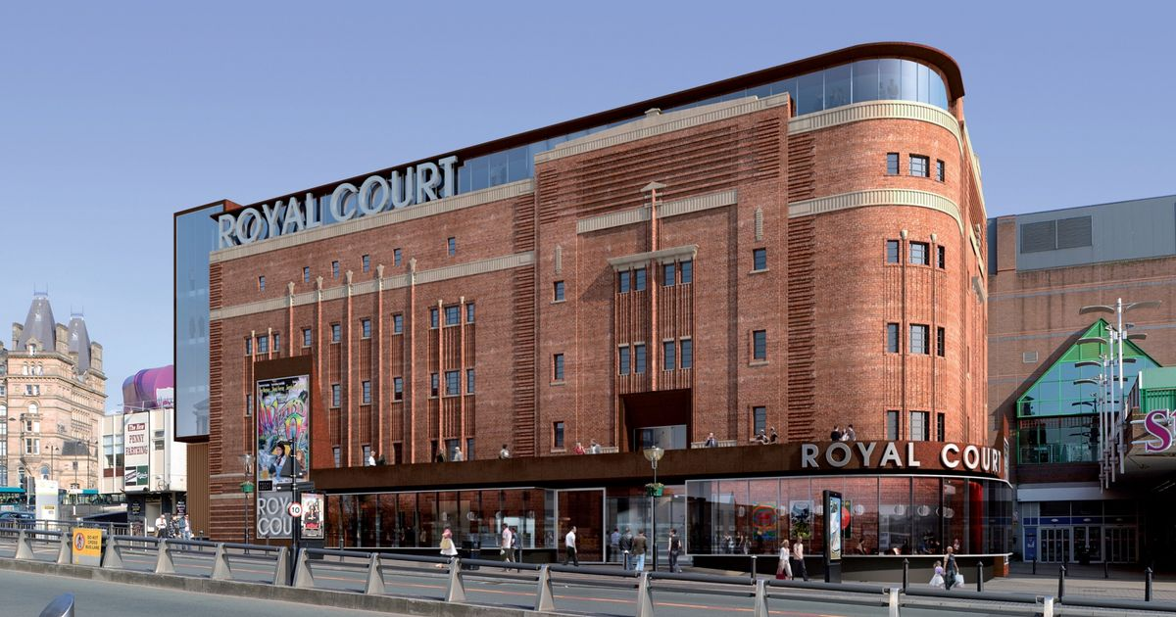
Name: | Jess Bolger
Position: | Creative Producer
Tel: | 0151 709 4321
Email: | jess@liverpoolsroyalcourt.com

Liverpool’s Royal Court

Artistic Policy
Liverpool’s Royal Court is a full-time producing house in the heart of the city centre. We began producing theatre in 2006 and have developed a unique style of theatre for Liverpool audiences, produced in Liverpool, primarily utilising Liverpool actors and writers. In 2018/2019, over 180,000 people visited the theatre and experienced the unique cabaret-style stalls seating, offering dinner and drinks before the show.

Alongside a programme of popular theatre, LRC has established wide-reaching community engagement programmes most of which are free to access with no waiting list and no auditions. These programmes provide arts activities to some of the most vulnerable communities in the region for all ages.

The majority of our work is new writing, commissioned and developed by us. We are happy to discuss ideas with writers, but our shows always focus on entertainment, mainly through comedy and reflect the warmth and humour of the people of Liverpool.

Our recently opened Studio space has allowed us to broaden our reach, producing a wider range of writing and themes and welcoming newer audiences. The Studio programme is a mix of in-house productions and hires.

Mission: To be known throughout the UK as a leading producer of quality theatre and inspiring engagement programmes for non-traditional theatre audiences. To be a key organisation through which audiences can develop a love for theatre in all its forms.

Purpose: Putting our audiences and participants at the heart of all we do. We bring joy and laughter to people by putting real Liverpool lives on stage, presenting our work in a unique way to engage non-traditional theatre audiences.

Belief: That our brand of theatre production and participation programmes can be enjoyed by most people whether they have had previous theatre experiences or not.

Core Values:
Liverpool’s Royal Court:
- Discovers and nurtures Liverpool talent on stage and off
- Creates high quality, made-for-audiences entertainment and participation activities
- Includes all audiences, especially those from low socio-economic backgrounds
- Shows the best of Liverpool to the world
How we support artists
We are always happy to meet and discuss with artists, particularly those in the Liverpool City Region, who think their work may be suitable for our programme. We are also seeking to model a more collaborative way of working across the city with other NPOs and smaller companies. We have a dedicated rehearsal space, set building workshop and extensive costume store and are open to discussing sharing resources with emerging companies in the area.

Seed commissions
We offer seed commissions for writers who approach us with an idea for a show that we think has the potential to be developed into a full production for our main house or the Studio. We will also look at good ideas that may not be perfectly suited to our audience but may have commercial potential through collaboration with other producers.

Stage Write
Our newly launched new writing programme has a number of strands aimed at developing writing talent in the Liverpool region. Our Playwright Development Programme is a 10 month, free to access course for Liverpool writers, it is broadly aimed at writers with some experience looking at creating their first full length play. The course runs February to November with fortnightly sessions. Applications open in November for the following year’s course.
We also run Stage Write showcase nights throughout the year, submissions can be made at any time and works selected will have an excerpt rehearsed with a professional cast and Director for a rehearsed reading.

Boisterous
Liverpool’s Royal Court support Boisterous, run by Maurice Bessman and Miriam Mussa. Boisterous is a development strand that aims to create work for and by artists of colour as well as collaborating on initiatives that increase the diversity of our organisation.

Mentoring Programme
This year we are piloting a mentoring programme for BAME artists and creatives in Liverpool. The scheme runs for 9 months and each participant is paired with a professional theatre mentor. The scheme will continue with annual intakes.

Spaces & Capacities
Venue |  |  |  | Capacity
Main Auditorium |  |  |  | 1105
Studio |  |  |  | 153
Seasons
Year round programming
How far in advance to contact us
Programming happens continuously so contact can be made at any time.

For Studio touring work / hires a minimum of 6 months.
We aren’t interested in booking…
We very rarely take external productions in the main auditorium.

In the Studio we are not interested in mixed bill comedy nights, hypnotists / mediums or live music.
The kind of financial deals we can offer
Straight hires or 70/30 Box Office splits for Studio pieces. We cannot offer travel or accommodation as part of any deals.
We like artists to make initial contact by…
E-mail, explaining what the work is, how it has been developed and why you think it is right for Liverpool’s Royal Court.
We prefer artists to contact us
By email | x | By phone |  |  | By post
Send weblink |  | Send DVD
If you approach us, you can expect…
We do our best to respond to all directly addressed approaches however we are a small team and may hold onto information until it is relevant / we are in a position to decide on it so it may be a while before we respond. If you are waiting on a decision from us then a reminder email is welcomed.

We will not generally reply to generic show information unless it is something we are interested in.

Programmer’s Contact Details |  | 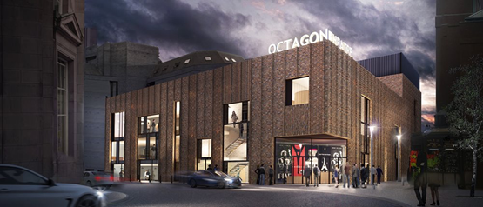
Name: | Catt Belcher
Position: | Producer
Email: | Catt.belcher@octagonbolton.co.uk

Octagon Theatre Bolton

Artistic Policy
Artist development is fundamental to achieving our aims and evolving new work for audiences. It is an
investment in culture and the long-term future of contemporary, relevant theatre in Bolton for existing
and new audiences. We support, develop and present work from an emerging generation of artists,
who are keen to experiment and develop new approaches to their work. Working with culturally diverse and disabled artists and local talent is important to us.

We have a flexible main house space (300-400) and a brand-new studio theatre (~88) which are
programmed at specific points during the year around our busy seasons of in-house work. We are
particularly interested in work which will help us to reach new audiences, support new and diverse
talent, and that will complement our seasons of popular, bold and adventurous work for the people of
Bolton and surrounding areas.

We primarily function as a producing house and regularly work with freelance creatives including directors, writers, movement directors, designers, and musical directors. We programme our main house when possible, and regularly programme our studio theatre across the weekends and school holidays.
How we support artists
We support artists through general auditions, local hiring, residencies, commissions, rehearsal space, in-kind advice and support, open script windows, creative engagement opportunities and more.

Find out about how we can support you here:
Artists and Freelancers | Octagon Theatre Bolton (octagonbolton.co.uk)

Spaces & Capacities
Venue |  |  |  | Capacity
Main House |  |  |  | 300 – 400 (dependent on seating configuration)
Studio |  |  |  | 80 – 90
Seasons
September – April, April - August
How far in advance to contact us
As early as possible, ideally 6-9 months in advance for studio programming
We aren’t interested in booking…
The kind of financial deals we can offer
All deals are negotiated.
In our studio we are best able to support a box office split or small-scale shows. Main house deals are more likely to be a guarantee against a box office split.
We like artists to make initial contact by…
- Programming Enquiries – programming@octagonbolton.co.uk
Your submission will be logged and discussed at our regular programming meetings.
Please try and include as much of the following information as you can:
  - Contact details
  - An invitation to see work/ recording of the work.
  - Information about the company, reviews, price and technical specification
  - Potential tour dates
- Casting – casting@octagonbolton.co.uk
- Artist Development – artist.development@octagonbolton.co.uk
We prefer artists to contact us
By email | x | By phone |  |  | By post
Send weblink |  | Send DVD
If you approach us, you can expect…
If you contact our Producer directly or via our Artist Development account, we will try our best to respond within 10 days.

Enquiries sent to the casting or programming email account will be read and logged; we will be back in touch should we wish to take your enquiry further. Do let us know in your email if you require a response by a specific date and we will do our best to help.

Programmer’s Contact Details |  | 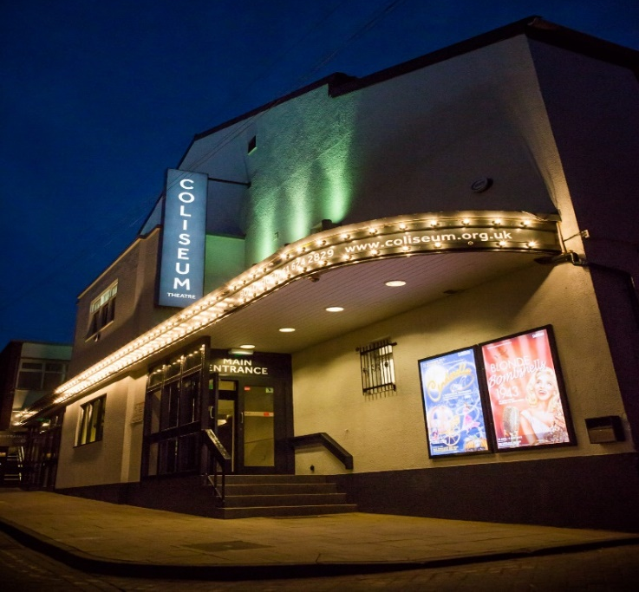
Name: | Jamie Walsh
Position: | Programme Coordinator
Tel: | 0161 785 7007
Email: | programming@coliseum.org.uk

Oldham Coliseum Theatre

Artistic Policy
The Coliseum is a thriving, accessible producing theatre, creating and presenting high-quality performance-based work. We also provide a far-reaching participatory programme, that integrates all aspects of the company’s work and engages the diverse communities of Oldham, Greater Manchester and further afield. The work of the Coliseum is informed by our values: creativity, inclusion, diversity, innovation, quality and an audience-focussed approach that encourages partnership working. We take a leading role in the social agenda of Oldham, driving the cultural offer and providing unique opportunities for professionals, audiences and different communities to come together and engage with the arts.
How we support artists
The Coliseum is committed to developing and supporting emerging artists and companies from across
the region and beyond to explore the stories and issues that affect, reflect and inspire our local communities.

We offer a number of opportunities throughout the year:
- Cultivate – A week-long artist development festival featuring workshops, open auditions and
industry insight opportunities.
- Culture & Chips – Monthly events for independent artists to connect with our Artistic team.
- Main House Takeover – A week of small-scale work showcased on the Main House stage.
- Scribbles - Weekly playwriting groups (for all levels).
- Two Script Submission windows (dates TBC).
- Response shows - written responses to the themes from Main House shows, performed on the
set for the production.
- Associate and Supported Artist programme – each year we commit to supporting a handful of
artists to achieve selected goals over a 12-month period.
- Advent Plays – an opportunity for writers and actors to create new short-plays for our annual Advent Calendar, shared across our social media and website.
- Assistant Directing and shadowing available for in-house productions (subject to availability).
- Rehearsal space – subject to availability.

The Studio programme runs alongside that of the Main House with a mix of new writing, visiting
companies, rehearsed readings, bespoke and in-house productions. We can also arrange for
companies to access and work with our community groups for R&D purposes.
Spaces & Capacities
Venue |  |  |  | Capacity
Main House |  |  |  | 505
Studio |  |  |  | 50
Seasons
September – March, April - August
How far in advance to contact us
6-12 Months. We welcome invitations to Work in Progress/Scratch Nights in order to get to know your work.
We aren’t interested in booking…
Large cast shows, we generally do not book adaptations of classic works
The kind of financial deals we can offer
Main House - Negotiable
Studio – 70/30 box office splits
We like artists to make initial contact by…
Programming email
We prefer artists to contact us
By email | x | By phone |  |  | By post
Send weblink |  | Send DVD
If you approach us, you can expect…
During the programming cycle the Artistic Team will aim to reply as soon as possible, if we are interested in programming or further discussions.

Unfortunately, due to the level of enquiries we receive we are unable to reply to every approach.
Attaching a tour pack will enable us to determine any potential interest early on.

Programmer’s Contact Details |  | 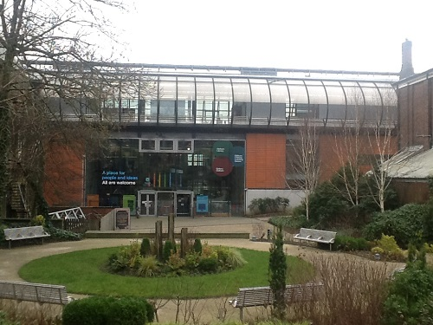
Name: | Katie Madden
Position: | Oldham Library Programmer
Tel: | 0161 770 8000
Email: | Katie.madden@oldham.gov.uk

Live@theLibrary at Oldham Libraries

Artistic Policy
Oldham Libraries’ live@thelibrary offer aims to showcase a diverse programme of artistic and educational performances. These cover a wide range of art forms, from drama, new writing, comedy, storytelling, digital theatre to author events.
We also feature and encourage performances by emerging artists. Crucially, we will ensure that the programme reflects the interests and aspirations of the local community.
How we support artists
Our lead contact will liaise with artists, offering advice, time, space and technical support. (charges for technical support will apply)

We also are keen to work with new artists and touring companies as part of our Open Space festival to give them a platform to showcase their projects.
Spaces & Capacities
Venue |  |  |  | Capacity
Oldham Library – Performance Space |  |  |  | 80
Community Libraries |  |  |  | 30
Seasons
Jan - April
May - July
Sept – Dec
How far in advance to contact us
6 - 8 months
We aren’t interested in booking…
Of shows which are cost more than a £1000
The kind of financial deals we can offer
We can offer a guarantee fix fee or a box office split of 70/30
We like artists to make initial contact by…
Please email us – providing information on the performance, target audience and costs
We prefer artists to contact us
By email | x | By phone |  | x | By post | x
Send weblink |  | Send DVD

Programmer’s Contact Details |  | 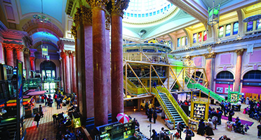
Name: | Amy Chandler
Position: | Producing Lead
Tel: | 0161 833 9333
Email: | amy.chandler@royalexchangetheatre.co.uk

Royal Exchange Theatre

Artistic Policy
Situated in the heart of Manchester, the Royal Exchange is an award-winning producing Theatre with a history spanning five decades. Our overarching vision is to be an internationally recognised centre of excellence for theatre in the UK and a vibrant cultural centre for Manchester and the region.
We inspire audiences by creating and presenting excellent work that brings together diverse approaches to storytelling with our unique spaces and developing different ways for artists, audiences, and participants to engage with our work locally, nationally and internationally. Known for producing classics such as William Shakespeare, Tennessee Williams, Oscar Wilde, Noel Coward, and Anton Chekhov, we're also one of the country's leading theatres for new writing.
We produce and present theatre and participation/learning programmes throughout the year including in our temporary venue The Den. This is work created and produced in collaboration with freelance creative teams and individual artists, other theatre companies and communities. Our work also transfers and tours nationally and internationally.
Each season we present a varied programme with a strong commitment to staging riveting revivals and championing new work.
How we support artists
Nurturing new talent, supporting artistic risk and investing in new ideas is a huge part of what we do.
Our artist development programme is built to reflect and enhance the quality and diversity of the Royal Exchange Theatre’s current work; bold, inclusive shows for diverse audiences as well as new work created by the most exciting artists, writers and makers. In 2020 we will be continuing to explore & develop additional opportunities & strands of work – updates will be posted on our website

To find out more about current opportunities https://www.royalexchange.co.uk/get-involved

WRITERS EXCHANGE
“If you live near Manchester and went to every single show…at the Royal Exchange, you’d have a pretty good grasp of what was going on in British theatre.” The Stage, July 2017

With over 180 premieres in its archive and a string of awards, the Royal Exchange Theatre has a rich history of supporting, developing and producing new work by playwrights at various stages of their journey as artists. Through an ambitious, diverse and bespoke programme of playwright support and new work, we endeavour to nurture and facilitate artistic risk and are dedicated to reimagining the relationship a producing theatre has with its audiences and artists.

The Royal Exchange Theatre is rare in our commitment to producing work by writers at different stages of their career. It is vital that writers are given the opportunity to benefit from a range of experiences and empowered to define what they feel would be most beneficial to their development as an artist.
Our aim is to develop and produce the best new plays and work for our stages from exciting and diverse voices. We commission a range of projects from some of the UK’s most exceptional artists, creating ambitious new work as well as vibrant new adaptations and translations of classics through which we strive to re-envisage our relationship to that work.

We also support artists through a range of partnerships with organisations such as New Earth Theatre Company, Graeae, Talawa and Eclipse which enables us to forge new relationships and bring new voices into the theatre.
We endeavour to support as many new and aspiring playwrights as possible through:
- Script Submission Windows are opportunities for playwrights to submit a script for feedback and to mark the start of a longer conversation and journey for both of us.
- Writing Resources for playwrights packed with online inspirations including things to consider when writing a play, tutorials and tips from experienced playwrights.
- Writers can also join the Open Exchange network to access workshops or opportunities to collaborate with other artists, directors and theatre-makers.
- Bespoke opportunities including Come Closer for playwrights to pen monologues as pop-up encounters and our Young Writers Programme for anyone aged 16 – 25 who is interested in writing plays, reading scripts and sharing their work.

THE BRUNTWOOD PRIZE FOR PLAYWRITING
The Royal Exchange Theatre is the home of the Bruntwood Prize for Playwriting, Europe’s biggest playwriting competition. Since its inception in 2005, over 15,000 scripts have been entered, £304,000 has been awarded to 34 prize-winning writers and 25 winning productions have been staged in 38 UK wide venues. At the heart of the Bruntwood Prize for Playwriting is the principal that anyone and everyone can enter the Prize – it is entirely anonymous and scripts are judged purely on the basis of the work alone and with no knowledge of the identity of the playwright. In 2015 it celebrated its 10th anniversary and is now recognised as a launch-pad for some of the country’s most respected and produced playwrights. The website associated with the Bruntwood Prize for Playwriting, www.writeaplay.co.uk, is designed to support anyone interested in writing for live performance and has a huge range of resources and a wealth of information, support and inspiration from blogs, courses and filmed workshops with some of the world’s most renowned playwrights such as Simon Stephens and Suzan-Lori Parks.
Spaces & Capacities
Venue |  |  |  | Capacity
Theatre (in the round) |  |  |  | 750 - 700
Studio |  |  |  | 90
Seasons
In 2022 Feb – July & Sept - Jan
How far in advance to contact us
Please note we are not booking any touring or externally produced work into our Studio in 2022.
In the autumn of 2022 we will be looking at plans for 2023
We aren’t interested in booking…
Clairvoyants, wrestling, tribute bands, commercial musicals. We also don’t hire our spaces to theatre companies for public performances; all work must be programmed into our artistic season. All work must be a Manchester - and ideally a North West - premiere.
The kind of financial deals we can offer
Box office split against a guarantee
We like artists to make initial contact by…
Email
We prefer artists to contact us
By email | x | By phone |  |  | By post
Send weblink | x | Send DVD
If you approach us, you can expect…
Any emails personally addressed to Royal Exchange staff will be responded to, but we often hold emails on file until we start programming the relevant season, so replies may come weeks or months later. Generically addressed emails will be read but only responded to if we are interested in the work. Please note that any emails with attachments totalling over 4MB may be blocked by our servers.

Programmer’s Contact Details |  | 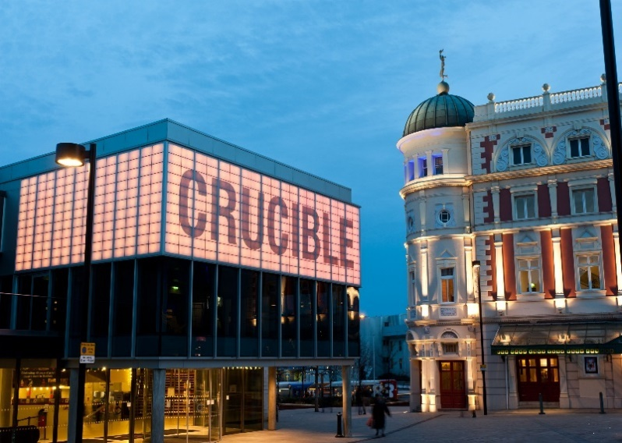
Name: | Helen Dobson
Position: | Programmer
Tel: | 0114 249 5999
Email: | programming@sheffieldtheatres.co.uk

Sheffield Theatres

Artistic Policy
One of the country’s leading theatres, Sheffield Theatres is home to the world-famous Crucible, Lyceum, and Studio Theatre. Taking pride in creating bold, passionate and enriching work across our three stages, we have been recognised for our ambition in 2013, 2014 and 2017 when we won the Regional Theatre of the Year Award in the Stage Awards, as well as 5 UK Theatre Awards in 2019.

Across the three theatres, we produce a diverse programme of work spanning a range of genres. We present a range of work currently on tour in the UK and work with theatre artists locally and nationally to nurture and develop new creative talent. We are proud to be at the forefront of presenting theatre performances that are accessible to all and have a longstanding commitment to equality and diversity on all our stages.

The multi-format Studio is used for presenting in-house work as well as programming a range of visiting work subject to season availability. There are normally between 4-6 spaces per season for visiting work. It is programmed on a season-by-season basis, and we have defined stages in the programming cycle to allow for a fair and transparent process. We have set criteria/objectives that we assess all submissions against, which are Artist Development; Audience Development; Creative Case for Diversity; Sales; Artistic Quality, and a successful submission will satisfy at least one of these criteria.

The Crucible is home to world class in-house productions. The stage is surrounded by seats on three sides and is used to showcase top quality productions made right here in Sheffield such as the award winning Everybody’s Talking About Jamie, Standing at the Sky’s Edge and Life of Pi. When available, this space is programmed on a rolling basis for single night shows, subject to our own producing schedules.

With over 100 hundred years of history our largest stage, the Lyceum Theatre, presents the very best theatre productions from the West End and Broadway. The Lyceum is programmed on a rolling basis showcasing week longs runs of drama, musicals and comedies.

How we support artists
In 2019 Sheffield Theatres launched The Bank, a talent development hub dedicated to supporting artists.

The Bank is Sheffield Theatres' creative space for local artists and theatre-makers to develop work, skills, collaborations and careers with the support of the staff, resources, and creative teams at Sheffield Theatres.

The Bank is also home to The Bank Cohort, a group of writers, directors, producers, and other creatives who are supported and mentored over 12 months in a programme culminating in industry showcases, seed funding for projects, and opportunities to work on Sheffield Theatres’ productions.

For up-to-date information about upcoming artist support schemes and details of how to get in touch please visit www.sheffieldtheatres.co.uk/for-artists.

You can also email talent.development@sheffieldtheatres.co.uk.
Spaces & Capacities
Venue | Capacity
Crucible | 925
Studio Theatre | In the Round – 389  Thrust – 274  End on – 182
Lyceum | 1,077
Seasons
Our seasons and submission windows are typically as follows:
Spring (January-May)
Submissions to be received by June the year before

Summer (May-August)
Submissions to be received by October the year before

Autumn (September-December)
Submissions to be received by February the same year
How far in advance to contact us
6-12 months for the Studio
We aren’t interested in booking
We don’t programme tribute bands, hypnotists, mediums etc. We’re unlikely to programme adaptations of classic texts. We also don’t hire out the studio, and all work is part of our season of programmed or produced work.

The kind of financial deals we can offer
Deals are negotiated subject to a number of variables, but we aim to provide modest guarantees and/or box office splits. We do not offer travel/accommodation on top or, or as part of deals.
We like artists to make initial contact by…
Email. We are very interested to hear why artists want to bring their work specifically to Sheffield Theatres, and why it would be a good fit in our programme. Please provide as much detail as possible – a tour pack with images, reviews and a short tech spec is great. Also, if you have a production trailer or a full recording of the show or previous shows, it will be a huge help.
We prefer artists to contact us
By email | x | By phone |  | By post
Send weblink | x | Send DVD
If you approach us, you can expect…
If emails have been addressed to someone personally at Sheffield Theatres, artists should expect a response via email once a decision has been made. Generically addressed emails will only be replied to should the work be of interest to us. Every submission received is considered, so it is only necessary to make contact once. Due to emails being filed by season of enquiry, there could be a wait of up to two months before receiving a response if outside the season currently being programmed. If a company’s work is unknown to us, we may ask to be invited to see some of your work before making a decision.

Programmer’s Contact Details |  | 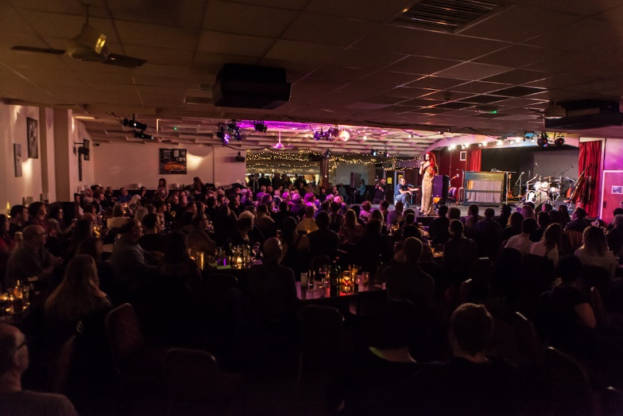
Name: | Alan Lane
Position: | Artistic Director
Tel: | 07305 155698
Email: | info@slunglow.org

Slung Low – The Holbeck

Artistic Policy
A programme of progressive work which otherwise might not get to be seen in Leeds
How we support artists
Rehearsal or R&D space at The Holbeck is open access to anyone who has need of it and can be requested via a simple online form on our website.
Anything we support should be able to meet at least one of these criteria:
- If the support of the Holbeck would clearly be of benefit to the artist requesting the resource, and that benefit can be clearly demonstrated by the artists. Our primary role is to support young and emerging artists.
- If the support of The Holbeck would result in an audience experience that might otherwise be missing from the city. One of our roles is to contribute (often as an outlier) to the healthy diversity of performances that are presented in the city.
- If a specific project or performance would encourage a new (and unlikely) audience to The Holbeck. One of our missions is to make sure that people who wouldn't normally consider a theatre somewhere they might visit always feel welcome at The Holbeck.
Spaces & Capacities
Venue | Capacity
Concert Room | 250 Seats (cabaret)
Lounge / Bar | 45 – 50
Snooker Room | 30
Seasons
Programme is all round.
How far in advance to contact us
At least two months.

We aren’t interested in booking…
Everything is considered, although primarily it leans towards new work.
The kind of financial deals we can offer
All performances are offered as pay what you decide with audiences paying after they have seen the performance. 100% given to artists in cash on the night and card payments when collated via BACS. Preferable (but not essential) that artists provide small quantity of print for internal and small local distribution.
We like artists to make initial contact by…
Marketing pack by email with links to work online rather than embedded. It is rare for us to “blind-programme” work so video clips, regardless of technical editing wizardry are always good to see.
It would be useful if artists could indicate something within the current or past programme which strikes a chord with the work they are looking to get shown, or some clear reason why their work should be shown in Leeds. Endorsements from programmers elsewhere are also helpful.
We prefer artists to contact us
By email | x | By phone | x | By post | x
Send weblink | x | Send DVD
If you approach us, you can expect…
A response within a couple of days, a kind welcome and a warming experience!

Programmer’s Contact Details |  | 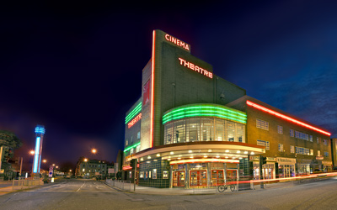
Name: | Amy Fisher or Fleur Hebditch
Position: | Producer, Assistant Producer & Literary Coordinator
Tel: | 01723356646
Email: | programming@sjt.uk.com

Stephen Joseph Theatre

Artistic Policy
Bold relevant and surprising theatre which inspires and entertains. As well as being a producing theatre we programme a variety of work from one-nighters to week long runs. Our main house is in the Round, which can also be sold in a 3-sided configuration. The McCarthy space also doubles as a cinema. We programme, theatre, comedy, music, spoken, word, dance and variety.
How we support artists
We offer a variety of development opportunities. We support artists by offering rehearsal space for
development, showcasing new work to industry professionals and the public, play readings and support for R&D projects. We also co-produce and run an open submission policy for new writing.
Spaces & Capacities
Venue |  | Capacity
The Round |  | 400
The McCarthy |  | 165
Seasons
Spring/Summer (Jan – Oct), Autumn/Winter (Oct – Jan)
How far in advance to contact us
We’re looking 12 months ahead at the visiting programme. So ideally you should get in touch 1 year in advance but that shouldn’t stop you contacting us as we sometimes are able to programme work within shorter periods.

The kind of financial deals we can offer
We offer a variety of deals dependent on the show and audience forecast which will be negotiated with the artist. This could take the form of a guarantee, a box office split, first call or a guarantee against a box office split.
We like artists to make initial contact by…
Email
We prefer artists to contact us
By email | x | By phone |  | By post
Send weblink |  | Send DVD
If you approach us, you can expect…
If your show is something that we would be interested in we will contact you either by email or phone.
Due to the volume of enquiries, we are not always able to respond to everyone. However, we do keep a record of all enquiries.

Programmer’s Contact Details |  | 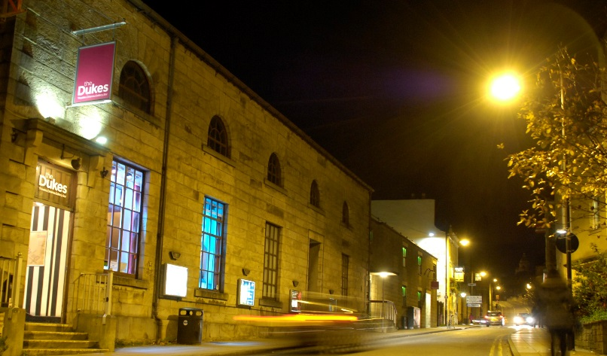
Name: | Karen O’Neil
Position: | Chief Executive
Tel: | 01524 598 500
Email: | programming@dukeslancaster.org

The Dukes, Lancaster

Artistic Policy
The Dukes’ mission is to bring the best in live performance and cinema to the communities of Lancashire in
our venue and other spaces. To create and actively support the opportunities for communities, individuals
and artists to develop their own creative work and its delivery. We aim to present a diverse collection of
storytelling through a range of art forms that delivers excellence, inspiration and challenge.

Through our touring programme our goal is to present a programme of exciting, diverse and progressive work.

Our touring programme is divided into two seasons, Autumn and Spring.

We are interested in:
- Drama
Split weeks of titles with name recognition, usually re-told with a twist and northern voice (eg classic novels in new adaptations, Shakespeare, well-loved plays). We are especially interested in Productions created for and performed in The Round.
- Contemporary Work in MoorSpace
In 2019 our Creative Learning building was renamed Moor Space and given a new identity and purpose and is now our home for contemporary theatre.
The contemporary theatre programme at Moor Space is an expansion of the current delivery of The Dukes and will allow us to present more diverse stories and provide a home for emerging local artists to experiment and explore their work. These artists and their work are reflective and focus on issues of wellbeing, mental health or present a conversation about the challenges with our society.
- Contemporary Dance
From 2021 we will be working to develop a contemporary dance offer at The Dukes. We are interested in dance or dance/theatre for all audiences including families.
- Family Work
Our offer to children and families focuses on small-scale monthly work for the under-5s and large-scale work twice a season for the over-5s.
Our monthly under-5s offer presents small-scale puppetry and storytelling-based theatre to provide an accessible and intimate first theatre experience for children and families. This work is presented in our Round theatre.

Theatre, comedy and dance are programmed into all three spaces.

We are interested in new work and also in production partnerships.
How we support artists
MOOR SPACE
The newest performance space in Lancaster, Moor Space is a place of cultural democracy where artists are invited to present their work in partnership with the Dukes. Focused on contemporary and new work MoorSpace is a place to develop ideas, practice and present work.

WORKSHOPS
The Dukes workshop programme is deliver by artists in response to artists.

OPEN SPACE
R&D space, time and support is available at the Dukes throughout the year. We are keen to support both local and regional artists and emerging companies. For more information, please contact Lauren.

RESIDENT COMPANIES
Are you a creative company in Lancaster or Morecambe looking for a home and the support of an
established creative organisation? If so please contact Karen.

CREATIVE COLLABORATORS
Creative Collaborators work with The Dukes across its diverse output from programming to creation of place to creative learning. We work closely with these artists to embed them in The Dukes and share our skills, knowledge and access to support their work.
Spaces & Capacities
Venue |  |  |  | Capacity
The Rake |  |  |  | 313
The Round |  |  |  | 230 full round/194 thrust/120 thrust with set
MoorSpace |  |  |  | 100
Seasons
Spring Jan – June
Autumn Sept - Dec
How far in advance to contact us
Autumn
Splits December-January
One-Nights: January-February
Programme Finalised: March

Spring
Splits July-August
One-Nights: August-September
Programme Finalised: September
We aren’t interested in booking…
Tribute bands, musical tributes, mediums, clairvoyants, choirs. We are unable to present live theatre June-August due to technical resources committed to our annual outdoor show.
The kind of financial deals we can offer
We can offer splits, minimal fees and guarantees but are willing to negotiate
We like artists to make initial contact by…
Email
We prefer artists to contact us
By email | x | By phone |  |  | By post
Send weblink | x | Send DVD
If you approach us, you can expect…
We shall respond my email.

Programmer’s Contact Details |  | 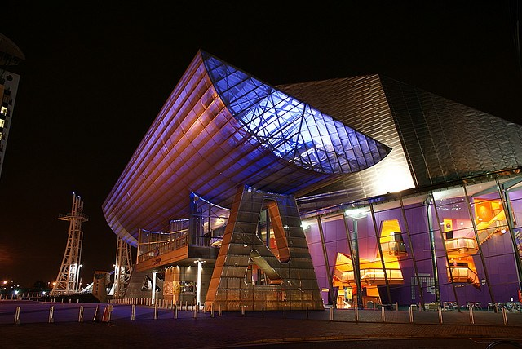
Name: | Antonia Beck / Matthew Eames /  Grace Ng
Position: | Senior Producer: Artist Development / Head of Theatres (Contemporary and Commissioning) / Assistant Producer: Artist Development & Equality, Diversity & Inclusion Lead
Tel: | Working from home
Email: | Antonia.Beck@thelowry.com  Matthew.Eames@thelowry.com  Grace.Ng-Ralph@thelowry.com

The Lowry

Artistic Policy
The Lowry is a large arts centre in Salford, Greater Manchester with three theatres programming a wide range of theatre, dance, circus, musicals, comedy, digital and cross-arts performance. Our Lyric and Quays theatre programme regularly features the latest productions from nationally and internationally renowned partners such as the National Theatre, Rambert, Birmingham Royal Ballet, Opera North, The Royal Court, Matthew Bourne’s New Adventures and Wise Children as well as the very best touring commercial theatre.

Alongside this, we welcome the freshest and most exciting work being made by emerging and mid-career theatre makers, performance artists and practitioners as part of our contemporary theatre programme. Newly created, innovative contemporary performance can be seen across all scales - Lyric, Quays and Aldridge Studio - encompassing and challenging all theatrical forms. Productions are often multi-disciplinary featuring physical, visual and digital practice, and stories old and new are told in innovative ways embracing linear and non-linear narratives and diverse cultural practice beyond the Western tradition. Contemporary circus, new writing, site-specific/responsive and immersive theatre, dance / movement-based work, new music theatre and the most experimental cross-arts practice are all celebrated in the context of the programme. The Lowry is able to offer audiences and artists/companies a through-line in exciting, relevant performance-making that leads from the newest, bravest artists touring at the small-scale, to the nationally renowned companies working at the mid-scale, to international companies in the Lyric.

We find work by seeing as many performances as we can, discussing and sharing recommendations with other programmers and producers, meeting artists, and considering approaches made by email though we’re less likely to book work from artists we haven’t previously seen.

We commission between eight and twelve companies a year through our artist development schemes and the premieres of their work form an important part of our programme throughout the year.

We also have a large outdoor and off-site programme working creatively with Salford communities to bring great performances to their doorsteps across the year – whether in parks, pubs or other public spaces.
How we support artists
The Lowry’s Artist Development Programme is a leading hub for the development of dynamic and exciting artists, creative practitioners, companies, and their work. The programme supports artists at all stages of their careers, working within the fields of contemporary performance, interdisciplinary performance practices, and socially engaged/participatory work. Nurturing talent and providing a range of bespoke pathways to develop and present work that is original, bold and dynamic to audiences at our home Salford, across Greater Manchester, and at venues across the UK and internationally.

ARTIST NETWORK
Artist Network is a free drop-in scheme for those who aspire to work creatively within the industry. Members are offered workshops, training, advice surgeries, ticket discounts and the opportunity to meet like-minded peers.

Who is it for?
- Independent artists and companies.
- Creative producers, project managers and administrators.
- Anyone with an aspiration to work creatively in the performing arts industry.

Register as a member by visiting the website to fill in the application form and equal opportunities form: thelowry.com/artist-network

DEVELOPED WITH THE LOWRY
Through Developed With, we offer five companies or artists a year-long package of support to help move their practice forward. We provide financial, technical and marketing support and space to support the production and premiere of a new show, and to help them secure a future life for the piece by advocating to our partners and hosting showcase events. Alongside this, we offer each company or artist a bespoke package of professional development support, with ringfenced funding to support them in developing their wider practice and processes through a range of activities such as placements, training courses, go-see trips, masterclasses or workshops with more established artists, mentoring sessions and attending conferences.

We recruit artists and companies we would like to work with throughout the year and will approach them directly to see if there is a good opportunity for us to work together. We will occasionally put out open calls for more specific opportunities – these are publicised through our Artist Network newsletter and website, Twitter, Arts News and through the networks of our partners in the industry.

UNTITLED RESIDENCIES
Untitled is a response to artists who needed dedicated time away to really delve deep into an idea in its early days – be it exploring a new collaboration across art form (including non-arts based); or across diverse artists or disciplines; or experimenting a new way of working or going rogue and disrupting a common practice and see what comes out of it. Giving artists the freedom to innovate by only focusing on the process – the messy, the mistakes, the warts and all – and not outcome. We offer week-long residencies and small pots of seed funding through this programme, with the application windows normally falling in Spring and Autumn each year.

Untitled Residency have been awarded to artists who are exploring:
- Ideas/Projects that are in the very early stages of development that will benefit from experimentation rather than rehearsal
- New or different collaborative approaches that would benefit from investment in-kind (space) and seed funding in order to strengthen a R&D funding application
- Artists/theatre makers who are underrepresented in terms of ethnicity, disability, sexuality, socio-economic backgrounds and any others who might need a different kind of courage to overcome historical barriers or perspectives.

ASSOCIATE ARTISTS
Our Associate Artist relationships are bespoke partnerships with artists and companies who want to tackle the challenges of our industry as well as develop their practice. Aimed at experienced mid-career artists and companies who are confident in their practice and their artistic voice, and who want to invest time and effort in a relationship with a venue in order to develop themselves and the industry at large.

Art forms that currently have a regional gap in artist development support: dance, new musicals, socially engaged work and contemporary circus
Spaces & Capacities
Venue |  |  |  | Capacity
Lyric |  |  |  | 1600
Quays |  |  |  | 450
Studio |  |  |  | 140
Lowry On Demand |  |  |  | A digital platform for online work engaging online audiences
Seasons
Jan to Apr, May to Aug, Sep to Dec
How far in advance to contact us
We programme finished touring work between nine months and a year in advance.
We are open to discussions about new projects from an early stage – please contact us once you have a plan and a clear sense of what you need to take the next step.
We aren’t interested in booking…
We don’t take hypnotists, magic shows, tribute acts or ice shows. We are less likely to book productions of well-known titles in the Studio as these are well represented on our other stages.
We do programme new writing productions but we don’t provide development opportunities or commissions for playwrights because as a receiving house, we don’t have the resources needed to take a script through to production ourselves.
We encourage writers to explore the excellent work of our neighbouring venues including the Octagon Theatre, Bolton and Royal Exchange Theatre.
The kind of financial deals we can offer
We offer a range of different financial deals from fees through to guarantees and splits depending on the needs of the work, our relationship with the artist or company and how confident we are that there is a strong audience for the work.
We like artists to make initial contact by…
We would prefer contact via email so that we can spend time considering your project when we won’t be disturbed or working against other deadlines.

If you have a finished show, send us:
- Tour pack including images, reviews, short tech spec (if you have them)
- But please don’t send documents larger than about 4MB because our inboxes are small.

If you are looking for support for a new show, tell us about:
- Your company and your experience to date
- Your proposed project and its audiences
- How the project will move forward your practice
- What kind of support you will need, bearing in mind that often we will be more able to give support in kind than cash.
We prefer artists to contact us
By email | x | By phone |  |  | By post
Send weblink |  | Send DVD
If you approach us, you can expect…
Any emails personally addressed to The Lowry staff will be responded to; generically addressed emails will be read but only responded to if we are interested in the work.

Programmer’s Contact Details |  | 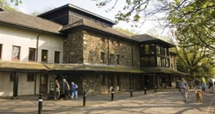
Name: | Amy Clewes
Position: | Producer
Tel: | 017687 81113
Email: | amy.clewes@theatrebythelake.com

Theatre by the Lake

Artistic Policy
TBTL’s Artistic Policy is currently being rewritten, following the development of a new business and programming model during the global pandemic. Please check our website for updates.

Theatre by the Lake is one of the most beautifully situated theatres in the world. It’s a creative hub for the communities of Cumbria and beyond, and the only producing theatre in the county.

Throughout the year TBTL produces and co-produces classic and contemporary plays, comedies and world premieres of new writing in the 400-seat main house (which can be transformed from an end-on proscenium arch to an in-the-round arena stage) and 90-seat Studio. Alongside this TBTL hosts a series of community projects, special events and visiting work in both spaces.
How we support artists
From our relatively isolated location in Cumbria, we work to help develop the work of artists, with a particular focus on artists and companies with links to Cumbria. Our talent development network, Cumbrian Creatives, currently numbers approx. 250 members and through this we’ve been able to offer a number of commissions, development and scratch performance opportunities. We’re also able to offer R&D space where available and are happy to share the knowledge and experience of our team in a variety of ways.

If you have any thoughts or ideas of how we can further support artists, do get in touch!
Spaces & Capacities
Venue |  |  |  | Capacity
Main House |  |  |  | 389
Studio |  |  |  | Between 80-100, dependent on configuration
FOH spaces |  |  |  | Approx. 40 – can work for participatory events
Seasons
N/A
How far in advance to contact us
As far in advance as possible, it takes us a while to slot our seasons into place
We aren’t interested in booking…
We’re unable to accept unsolicited texts or plays
The kind of financial deals we can offer
We prefer direct splits or calls on box office if possible, especially in the Studio, but can offer guaranteed fees depending on the show.
We like artists to make initial contact by…
Emailing a tour pack to our dedicated programming address – programming@theatrebythelake.com. Ideally this will include tech info, the sort of deal you usually look for, and any other key info (although we’re aware not everyone has this info at the time of enquiry)
We prefer artists to contact us
By email | x | By phone |  |  | By post
Send weblink | x | Send DVD |  | x
If you approach us, you can expect…
A friendly reception! We try and respond to everyone who gets in touch, regardless of if we’re able to programme your show, although it may take us a little while as we’re a small team. Generically addressed emails will be read but only responded to if we’re interested in the work.

Programmer’s Contact Details |  | 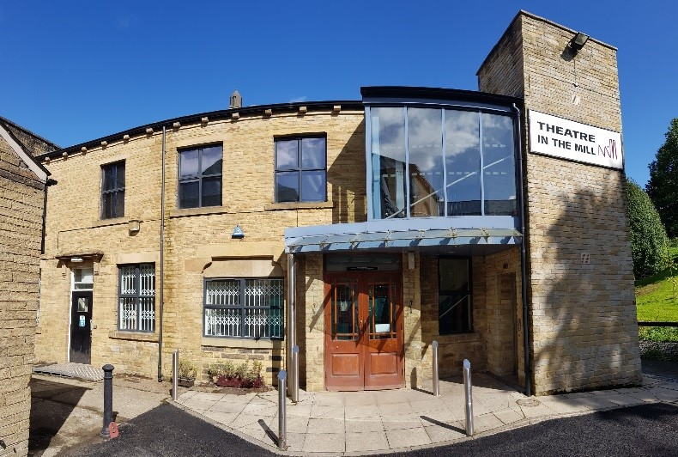
Name: | Rich Warburton
Position: | Artistic Director
Tel: | 01274 233186
Email: | r.warburton@bradford.ac.uk

Theatre in the Mill

Artistic Policy
At Theatre in the Mill, we are committed to presenting, developing and supporting socially responsible work that engages with the environment within which we are situated. We strive to create spaces that promote dialogue and art that represents the narrative of the people, the city and the region around us. We believe in the need for our audiences to see themselves represented in contemporary culture and that we have a responsibility to be a mirror that reflects the lives of those around us. We are also excited about the future and welcome work that is innovative in form, practice and technology. We commission and support work which we think reflects these values and beliefs.

Theatre in the Mill commissions and supports artists across a range of artistic forms, and we are keen to continue expanding the group of artists we work with to include new, diverse voices. We are excited by practitioners who approach their work with curiosity and rigour, are interested in creative and thoughtful approaches to accessibility in their work, and whose reasons for wanting to work in Bradford are clear. We prefer to engage with artists early on in the development of a new work, or new way of working, and we expect all artists to be willing to exchange with other creatives, engage with our audiences and help us to create an ethos of shared learning and resource
How we support artists
We don't have a one size fits all policy and so each relationship we have with an artist is developed around their needs both artistically and emotionally. We are interested in supporting both artist and project development, which we do through the offer of cash commissions residencies, advice, advocacy and more. We have a small but talented core team who can offer artistic support and feedback, as well as setting up work-in-progress sharings. We often write letters of support to accompany ACE project grant applications for artists we are supporting, and provide support and advice as they write funding bids.

We also put them in touch with other creatives who we think it would be great for them to chat to or work with. We also want to provide artists with the opportunity to access the expertise that is at home at the University of Bradford; we are able to broker relationships with academics and departments where we can see that this engagement will be mutually beneficial. Operating within the University also gives us access to cutting-edge technological resources and expertise, so please chat to us if you’re interested in that.

We also support artists by being flexible and prioritising their needs; we never demand a visible output at the end of a residency, and we are always happy to adjust plans in response to artists’ wellbeing needs.
Spaces & Capacities
Venue |  |  |  | Capacity
Theatre in the Mill Studio |  |  |  | 80
Tiny TiM |  |  |  | 1 on 1 performances
TiM Below |  |  |  | 30
Gallery II |  |  |  | 56
Seasons
We present work as part of Weekenders: themed long weekends where all of our spaces are used to create micro-festivals of around 8-10 pieces of work that are connected by a theme. That theme may be form (e.g., live art), identity-based (e.g., queer work) or circumstantial (e.g., work heading to the Edinburgh Fringe). As part of our artist development drive, we programme these Weekenders in response to the work developed by artists we’re supporting, and the work presented will be from artists we have an ongoing relationship with (whether long-standing or new). Performing alongside other artists making work with a connection with yours, we hope, will spark dialogue - perhaps artistic collaborations, perhaps sharing audiences in exciting new ways. In short, we want everything we do to be about support and growth - including presenting work.
How far in advance to contact us
We are particularly interested in chatting to artists at early stages of R&D; we can book in last-minute rehearsal space or residencies but would ideally have at least 6 weeks of lead-in time in order to better support you. When programming our Weekenders, we primarily look at work we supported the development of; however, if you’re interested in an ongoing relationship with us and would like to be programmed as part of that, we programme Weekenders 3-6 months in advance.
We aren’t interested in booking…
Since we do not define as a new writing theatre, and do not have a literary department or similar support for script development, we are not looking for new plays. Similarly, as a theatre whose largest space is an 80-seater studio, we are unable to offer rehearsal or performance for larger-scale work. Finally, we are also not looking for artists remounting existing productions as we are committed to the development of new work. However, if you’re unsure about whether your project aligns with our values and aims then get in touch and we can talk it through.
The kind of financial deals we can offer
We offer between £1,000 and £4,000 per commission, dependent on the scale, remit and context of the project. The more closely it aligns with our core values and relevance to our context here in Bradford, the more likely an offer is. Artists programmed as part of our Weekenders receive a flat rate of £500 per performance, and we try to offer multiple performances per Weekender.
We like artists to make initial contact by…
Emailing us, dropping by, chatting to us at an event here or elsewhere. Wherever you come across us, have a chat and we’ll follow up by email.

We run a dedicated drop in Open Office over zoom every Tuesday to Thursday 10am-11am (This was daily during lockdown and will operate in the same way if we have to return to a working from home only model).

The link is: https://us02web.zoom.us/j/220257517 Meeting ID: 220 257 517
We prefer artists to contact us
By email | x | By phone |  |  | By post
Send weblink |  | Send DVD
If you approach us, you can expect…
Any emails personally addressed to Theatre in the Mill staff will be responded to; generic emails will be read but only responded to if we are interested in the work. We try and meet with all artists who wish to meet who we believe reflect the type of work we value and support. We are a small team with limited capacity so we cannot always respond immediately to requests.
If you haven’t been responded to please use the open office link to get in touch.

Programmer’s Contact Details |  | 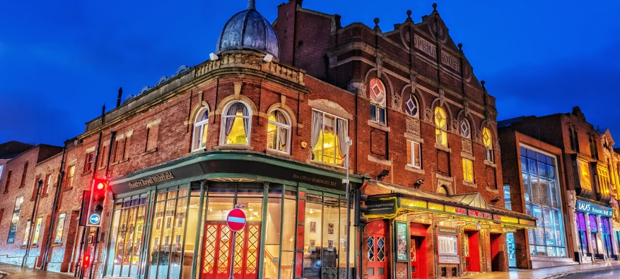
Name: | Emma Proctor
Position: | Communications & Programme Manager
Tel: | 01924 215 531
Email: | programming@theatreroyalwakefield.co.uk

Theatre Royal Wakefield

Artistic Policy
Theatre Royal Wakefield’s mission is to develop new creative opportunities and experiences in our theatre building, throughout the wider community and on tour, encouraging high quality engagement in the Performing Arts.

We programme shows for families, for fans of music, drama, comedy and more. Our stage is usually occupied 265 days of the year and some of the work is made by us, right here in Wakefield (like our hugely popular pantomime). The rest we hand pick from the best that the UK has to offer. Theatre Royal Wakefield is for everyone, that’s why we are also proud to present work from our local community, amateur societies and groups on our stages. Not only that but we take our productions around the UK too, spreading the Wakefield name far and wide!

Our Creative Director is John Godber, award winning writer of Bouncers, Teechers, and Up ‘n’ Under, and together with the John Godber Company we have co-produced many of his plays, one of which had an extended run in London’s West End in 2019 (Scary Bikers).

As well as a vibrant and varied programme of produced and touring work, we run a busy Learning and Participation programme. We regularly work with young people, socially isolated older people, refugees and asylum seekers and adults working to improve their mental wellbeing.

We are embedded in our local community and have a brilliant team of more than 140 volunteers, who not only give loyal support but also excellent service to our audiences.
How we support artists
We support artists by offering a flexible space for development, showcasing new work, play readings and support for R&D projects.
Spaces & Capacities
Venue |  |  | Capacity
Matcham Auditorium |  |  | 499
Walker Studio |  |  | 40 - 60 (depending on seating layout)
Seasons
Spring (mid Jan-Apr), Summer (May – early Jul), Autumn (mid Sep – early Nov)
How far in advance to contact us
Our dairies are open 1-2 years in advance
We aren’t interested in booking…
Hypnotists
Mediums
Roy Chubby Brown or similar
Wrestling
John Godber adaptations
The kind of financial deals we can offer
Split deals
Hires
Guarantees against splits
First calls
All deals are negotiable
We like artists to make initial contact by…
Email
We prefer artists to contact us
By email | x | By phone |  |  | By post
Send weblink | x | Send DVD
If you approach us, you can expect…
If emails have been addressed to the programming team at Theatre Royal Wakefield, artists should expect a response via email once a decision has been made. Generically addressed emails will only be replied to should the work be of interest to us.

Programmer’s Contact Details |  | 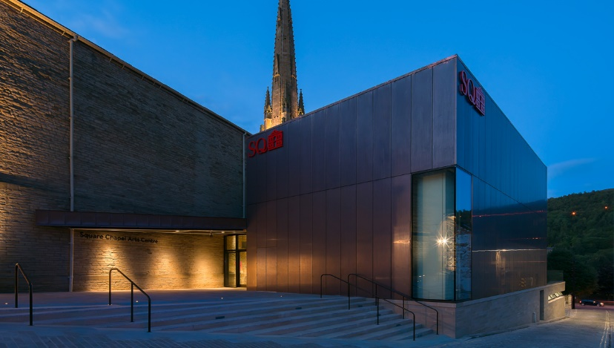
Name: | Jonny Davenport
Position: | Artistic Director
Email: | davenportj@theoldcourts.com

The Old Courts Wigan / Square Chapel Halifax

Artistic Policy
To engage with artists and companies who share our passion for showcasing impactful, relevant and thought-provoking work to an ever-diversifying audience
How we support artists
Varying levels of support bespoke to the artist
Spaces & Capacities
Venue |  |  | Capacity
TOC The Victorian Courtroom |  |  | 100 seated
TOC The Studio Theatre |  |  | 150 seated
TOC The Grand Vault |  |  | 120 seated / 300 standing
SC Red Brick Auditorium |  |  | 250 seated / 400 standing
Seasons
JFMA/ MJJA/ SOND
How far in advance to contact us
6-12 Months
We aren’t interested in booking…
impoliteness
The kind of financial deals we can offer
Hires / splits / guarantees
We like artists to make initial contact by…
Email to arrange call / in person
We prefer artists to contact us
By email | x | By phone | x | By post
Send weblink |  | Send DVD
If you approach us, you can expect…
Enthusiasm, a busy team who will make time for you, Energy.

Programmer’s Contact Details |  | 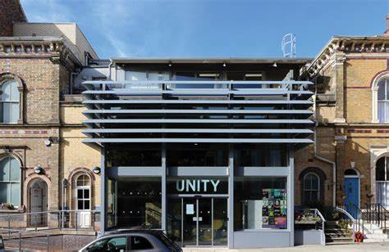
Name: | Gordon Millar
Position: | CEO / Artistic Director
Email: | info@unitytheatre.co.uk

Unity Theatre, Liverpool

Artistic Policy
We produce and present innovative combined arts that challenge the status quo. More details of our ever-evolving practices can be found at www.unitytheatreliverpool.co.uk
How we support artists
Rehearsal and R&D space is available to hire. In addition, we have a free creative membership called ‘Creative Pool’ with benefits including subsidised tickets and free workshops.
All details of this can be found online
Spaces & Capacities
Venues |  |  |  | Capacity
Unity 1 |  |  |  | 150
Unity 2 |  |  |  | 88
Seasons
All year except January and August
How far in advance to contact us
9 months
We aren’t interested in booking…
Everything is considered though we prefer the contemporary to classics and prefer wok that is innovative and challenges the status quo
The kind of financial deals we can offer
Fees, splits and hires
We like artists to make initial contact by…
Email
We prefer artists to contact us
By email | x | By phone |  |  | By post
Send weblink |  | Send DVD
If you approach us, you can expect…
To hear back from us withing 2 weeks but please be aware we are inundated with requests so might be longer

Programmer’s Contact Details |  | 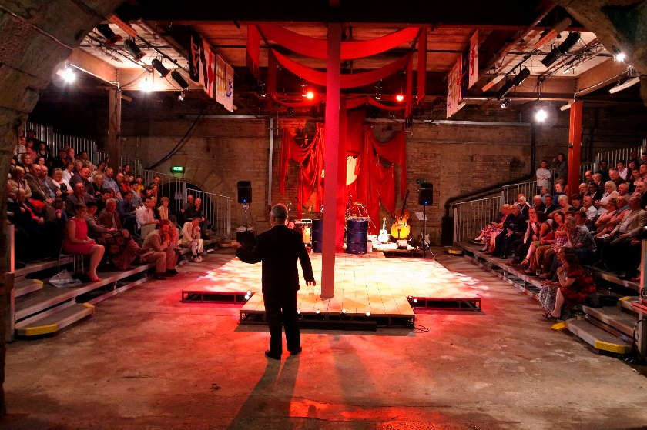
Name: | Sarah Horsley
Position: | Executive Director
Tel: | 01422 849227
Email: | sarah@viaducttheatre.org.uk

The Viaduct Theatre

Artistic Policy
The Viaduct Theatre is a unique subterranean space buried deep underneath the prestigious Dean Clough Mills in central Halifax. The Theatre was established nearly 30 years ago by renowned resident Theatre Company, Northern Broadsides, whose mixed touring programme of Shakespearean productions, adapted classic plays and new writing in a northern voice have built a significant following. Northern Broadsides initially recognised the potential of this raw and atmospheric post-industrial performance space and perform here regularly. We programme drama & new writing in the main auditorium and are open to more event-based programming in the new Traverse Bar.
How we support artists
In various ways, depending on need. Previous support has included in the loaning of rehearsal space, administration support, marketing support and mentoring.
Spaces & Capacities
Venue | Capacity
Main Auditorium (set in traverse) | 305
Traverse Bar | 50 - 80
Seasons
Spring/Summer & Autumn/Winter
How far in advance to contact us
As far as possible
We aren’t interested in booking…
Dance – our spaces are not suitable
The kind of financial deals we can offer
Ideally strive to meet personalised deals that suit both parties. We occasionally offer dry hire, but prefer to programme.
We like artists to make initial contact by…
Email
We prefer artists to contact us
By email | x | By phone |  | By post
Send weblink | x | Send DVD
If you approach us, you can expect…
We aim to respond positively to all applications to perform in our spaces with appropriate feedback.

Programmer’s Contact Details |  | 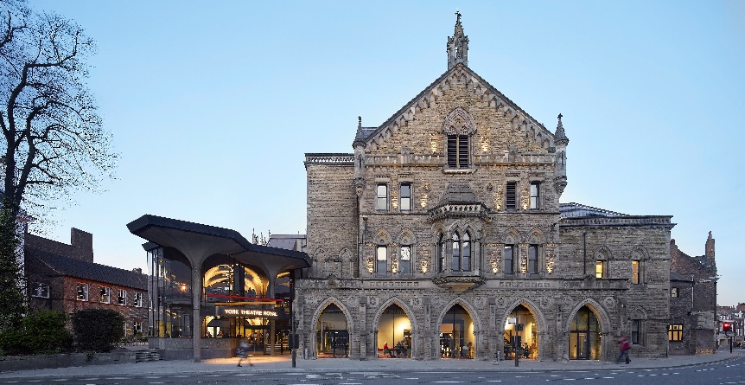
Name: | Thom Freeth
Position: | Producer
Tel: | 01904 658 162
Email: | programming@yorktheatreroyal.co.uk

York Theatre Royal

Artistic Policy
York Theatre Royal is an ambitious 277-year-old producing and presenting theatre with two end-on stage spaces.

The theatre presents a diverse range of work across the main stage and studio including drama, panto, musicals, dance, live music, comedy, locally based amateur companies and guest speaker events.

As well as producing exciting and engaging theatre as part of our main stage programme, we work with a number of other UK theatre companies, such as Wise Children, on co-productions throughout the year.

We also produce large scale outdoor productions for the communities of York and the surrounding area to come together and participate in.
How we support artists
As part of our artist development scheme, we are committed to supporting new artists and companies in the region, by developing their ideas and work with us at York Theatre Royal. We offer a number of opportunities throughout the year which promoted via our social media and website (www.yorktheatreroyal.co.uk).

York Theatre Royal is keen to support a diverse range of artists with a focus on new Studio-scale work by global majority and York based theatre makers. We’re specifically interested in digital work, theatre which engages with environmental issues, locally relevant work and theatre for young people.

York Theatre Royal’s Studio is a flexible space which is used to present small-scale touring work; to deliver youth theatre and creative engagement sessions; and as space to support theatre makers in the development of work.

Artists can join our open network at artistdevelopment@yorktheatreroyal.co.uk to be first to hear about all further opportunities as part of York Theatre Royal's Artist Development Scheme.
Spaces & Capacities
Venue |  |  |  | Capacity
Main Stage |  |  |  | 720 - 760
Studio (end on with retractable theatre seating or flexible black box theatre space) |  |  |  | 70
Seasons
All year except January and August
How far in advance to contact us
6 - 9 months
We aren’t interested in booking…
Sporting events, Magicians, tribute acts
The kind of financial deals we can offer
Guaranteed fees, calls, splits and hires.
We like artists to make initial contact by…
Email
We prefer artists to contact us
By email | x | By phone |  |  | By post
Send weblink | x | Send DVD
If you approach us, you can expect…
It’s worth noting that our programming is looked after by an artistic planning team instead of an individual, all suggestions will be considered by the Artistic Planning team, but we may only be able to get in touch if the team feel your show is right for our programme, audiences and works in terms of date availability.

Programmer’s Contact Details |  | 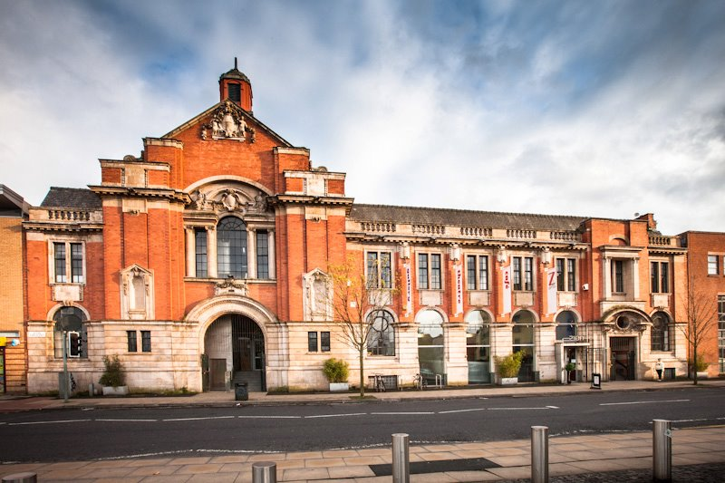
Name: | Zoe Pickering
Position: | Head of Programming and Big Imaginations Manager
Tel: | 01612 261 912
Email: | zoe@z-arts.org

Z-arts

Artistic Policy
Z-arts are Manchester’s venue for children and families and only programme work for that audience, although it is possible to hire the venue for other work. We also lead and coordinate the Big Imaginations network of venues across the North West and west / South Yorkshire, who all share a commitment to bringing brilliant touring children’s theatre to the region.
How we support artists
Z-arts mission is to inspire and enable generations of young people from Manchester and beyond to
utilise creativity to maximise their potential.

Artists are nurtured and supported by Z-arts to make excellent, contemporary theatre, performance and arts activities for children and families, through these strands:
- Artist development programme including residencies delivered with partners
- Creative facilitator training programme
- Space available for artists making work for children and families
- Commission opportunities for new work for children and families
- Artist support and commission opportunities with the Big Imaginations network for 23 organisations across the North-West / Yorkshire

If Artists are making work for children then we will always look at what support we can offer.
Spaces & Capacities
Venue |  |  |  | Capacity
Z-arts Theatre |  |  |  | 225 (Socially distanced 104)
Seasons
Spring Jan – Apr / Summer May- Aug / Autumn Sept- Dec
How far in advance to contact us
As soon as you have something to talk about or share. Invite us to any R&D, tours – we need to see the work. We generally programme 6-12 months in advance, at the moment that can vary.
We aren’t interested in booking…
Anything that isn’t for children and families.
The kind of financial deals we can offer
We offer all of our companies a fee.
We like artists to make initial contact by…
Email
We prefer artists to contact us
By email | x | By phone |  |  | By post
Send weblink |  | Send DVD
If you approach us, you can expect…
An email response. We will let you know what further information we need.

Genre Matrix

This edition of Routes In: A guide to getting new work programmed in the North of England was published by Venues North in January 2022.

We hope you have found it useful. If you have any questions, suggestions or comments about how we can improve it, please email:

annabel.turpin@arconline.co.uk

This edition of Routes In: A guide to getting new work programmed in the North of England was published by Venues North in January 2022.

We hope you have found it useful. If you have any questions, suggestions or comments about how we can improve it, please email:

annabel.turpin@arconline.co.uk

